**Case 1:**

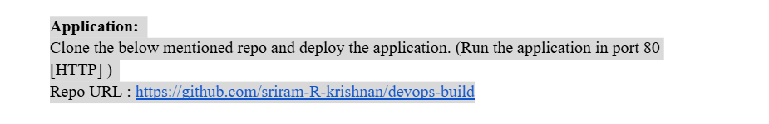

**Cloning the application using Git clone command:**

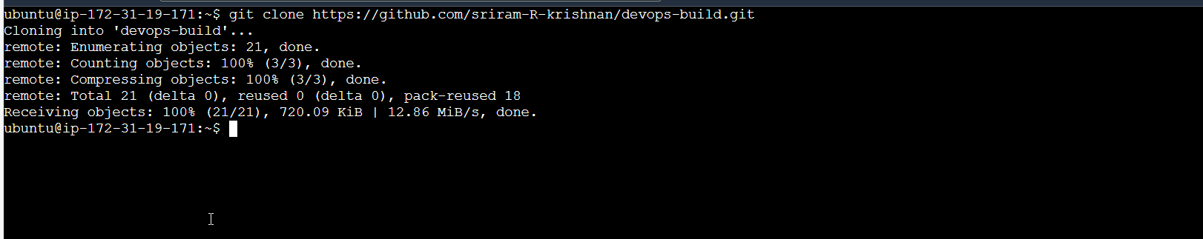

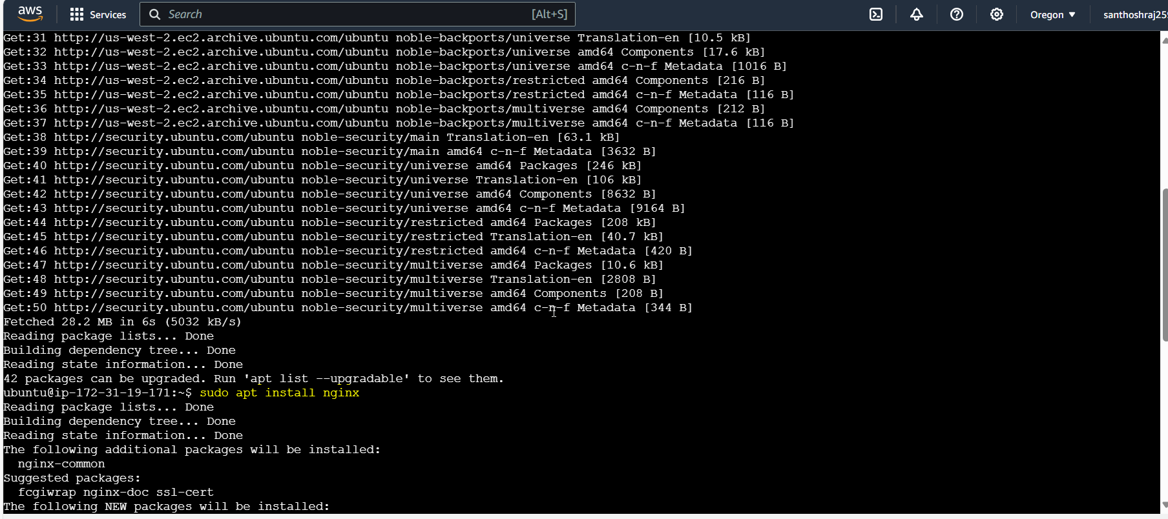

Moving files to /var/www/html where the nginx is configured to run the application:

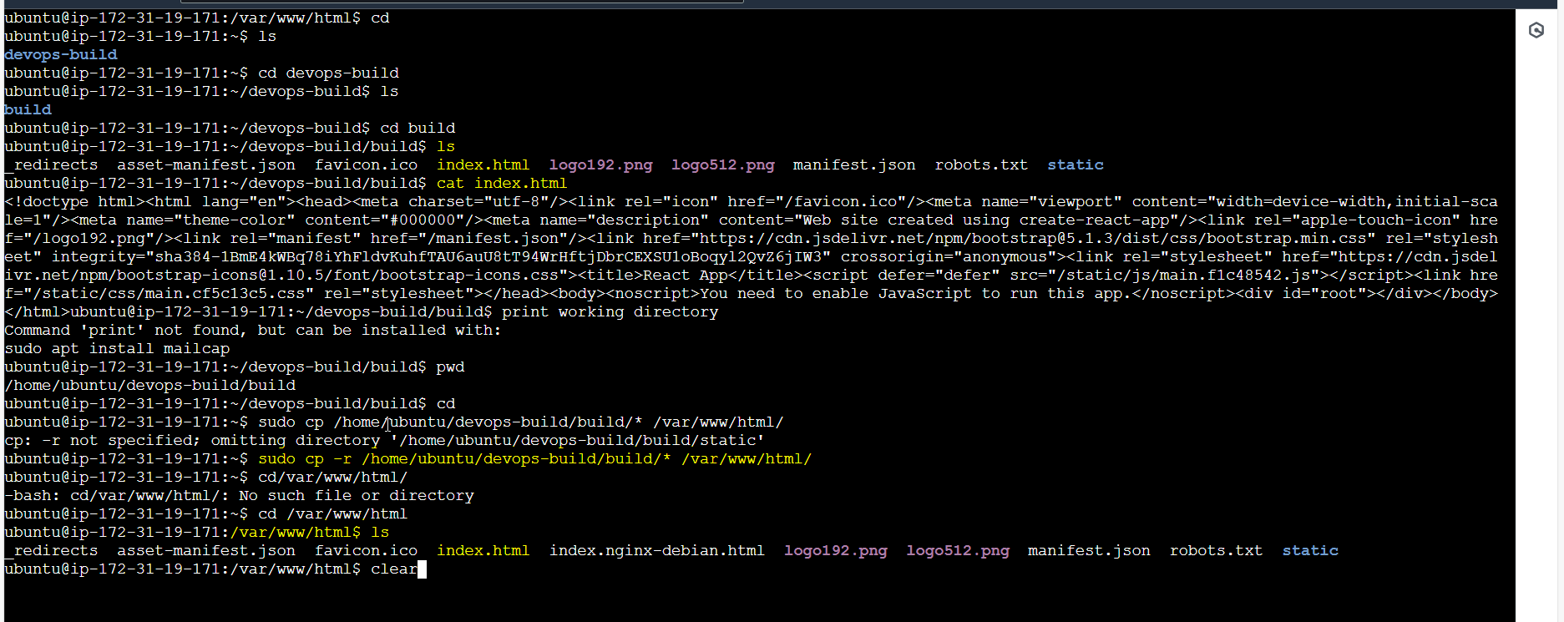

Starting the service nginx which is running in port 80:

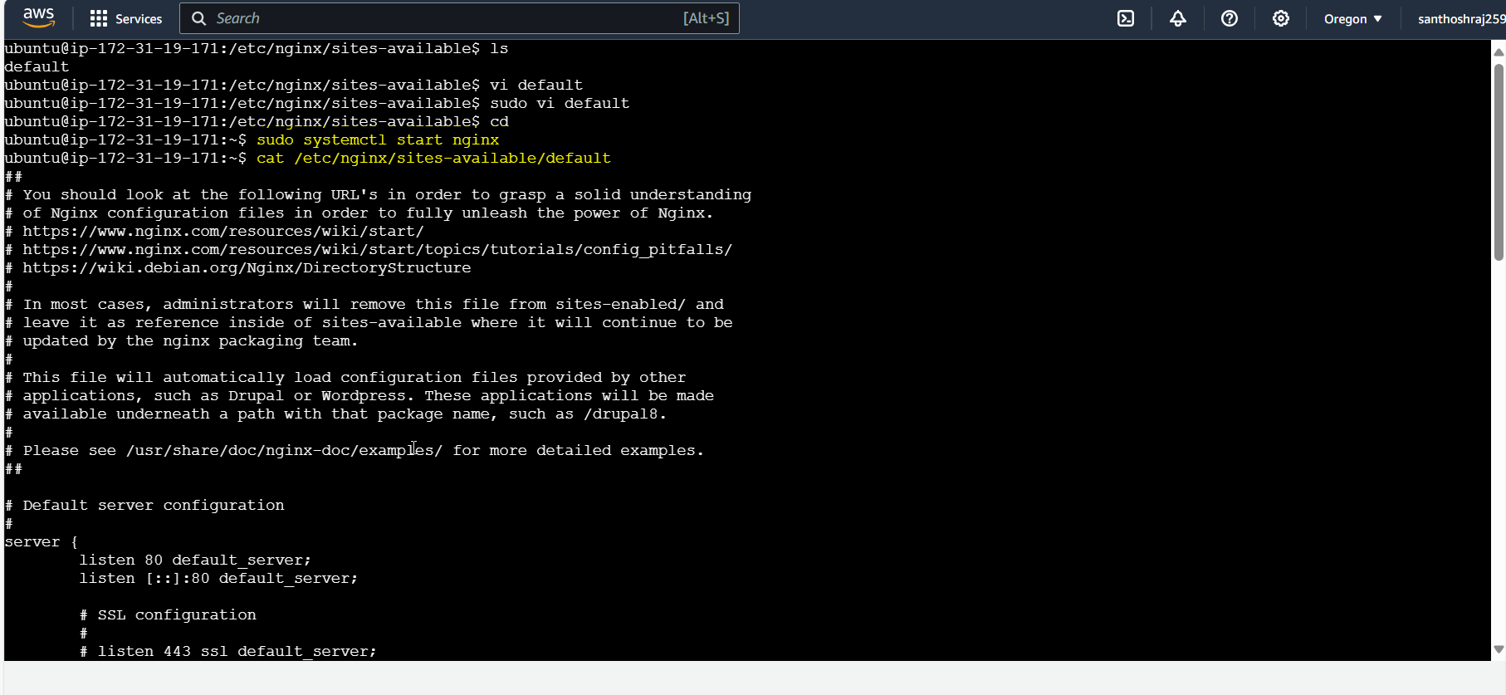

Allowing SG inbound rules to allow the Port:80. 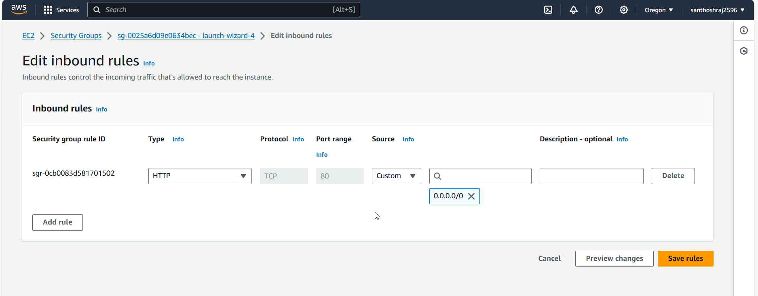

Your application is running in Port:80 with Public IP.

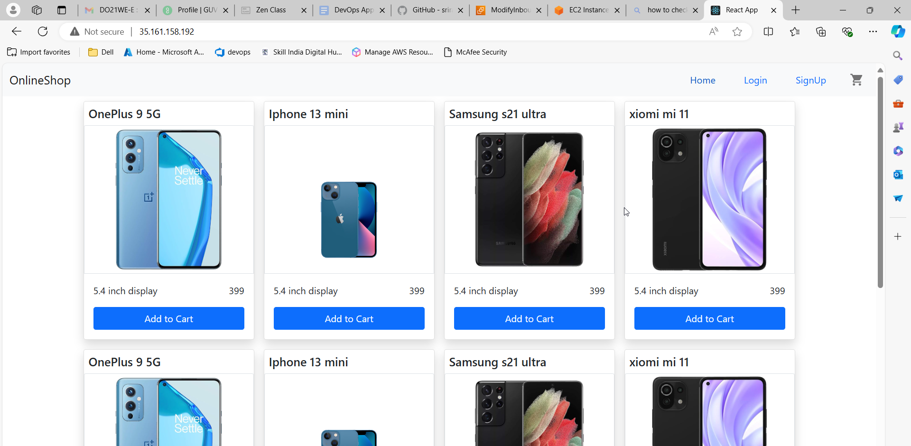

**Case 2:**

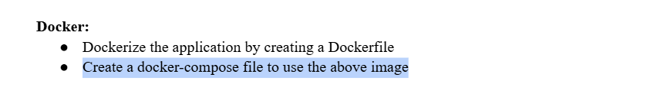

Creating dockerfile

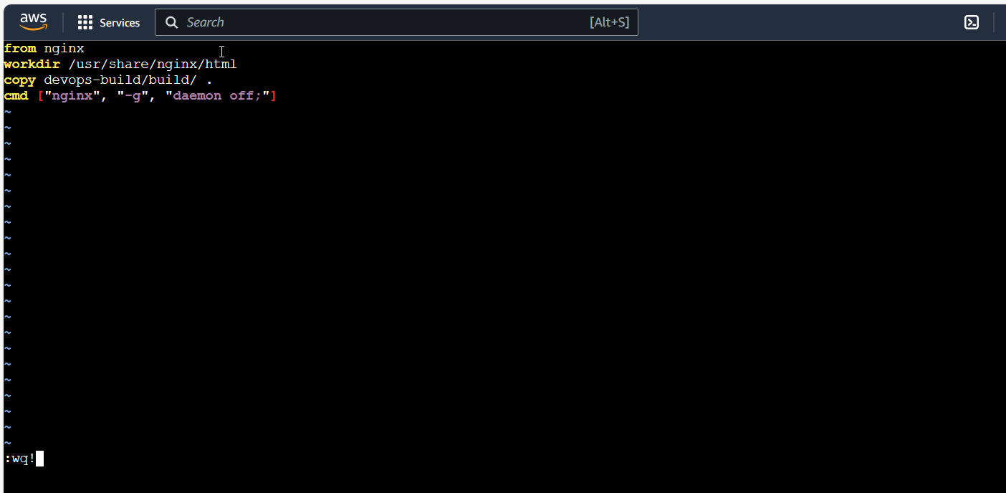

Build image:

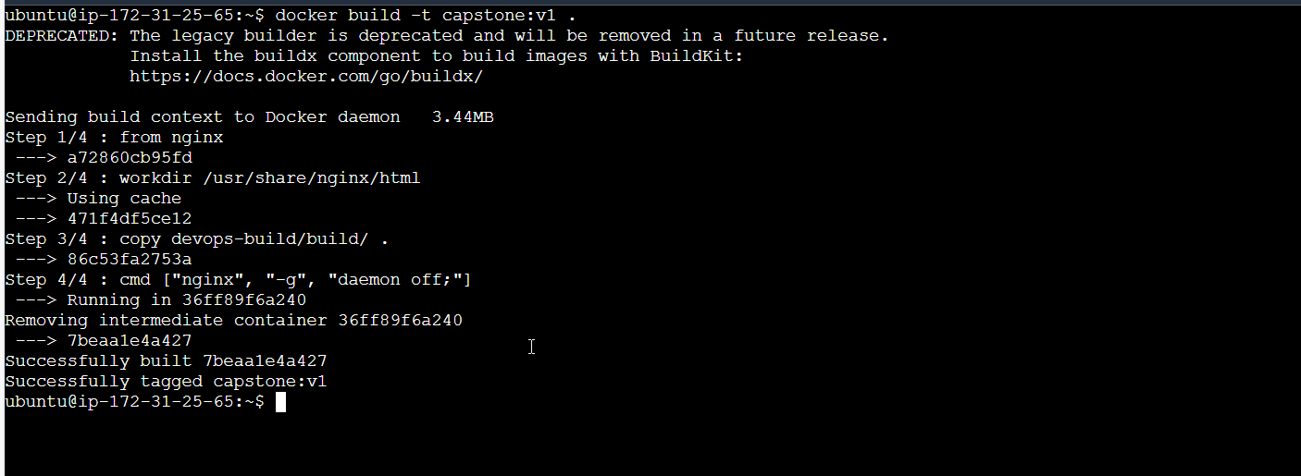

Image:

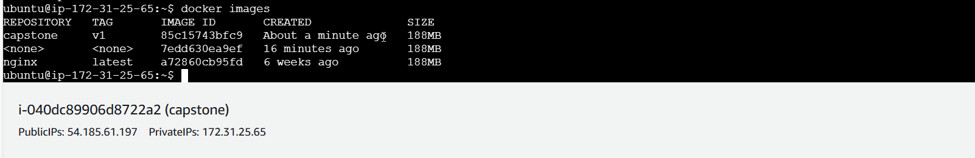

Docker-compose file:

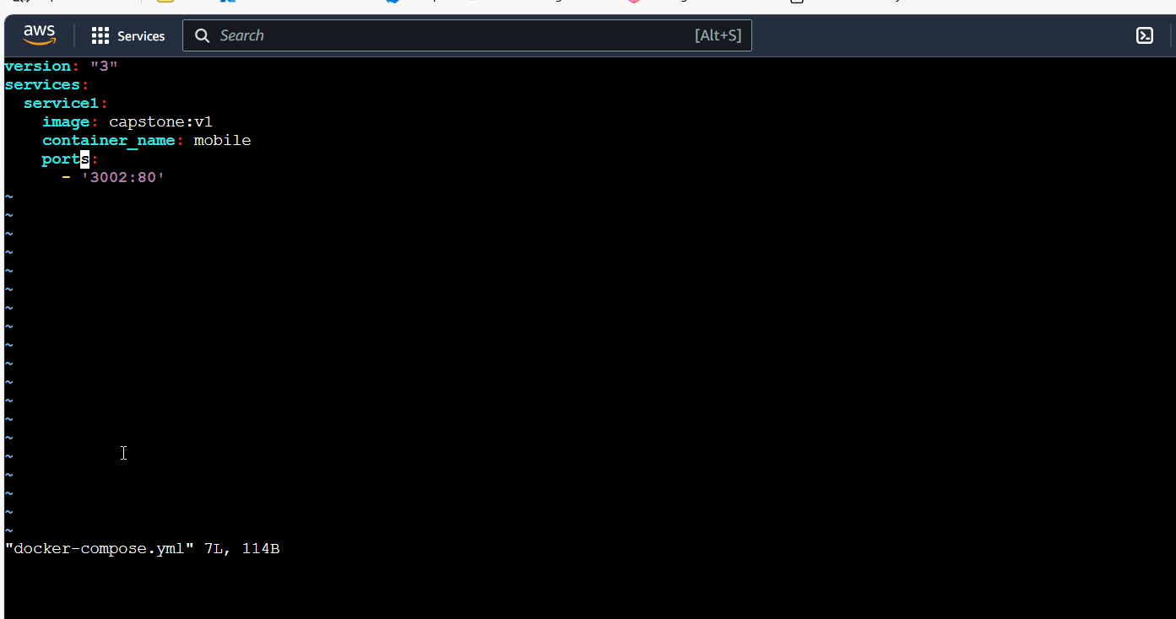

While building docker-compose file, facing API server issue:

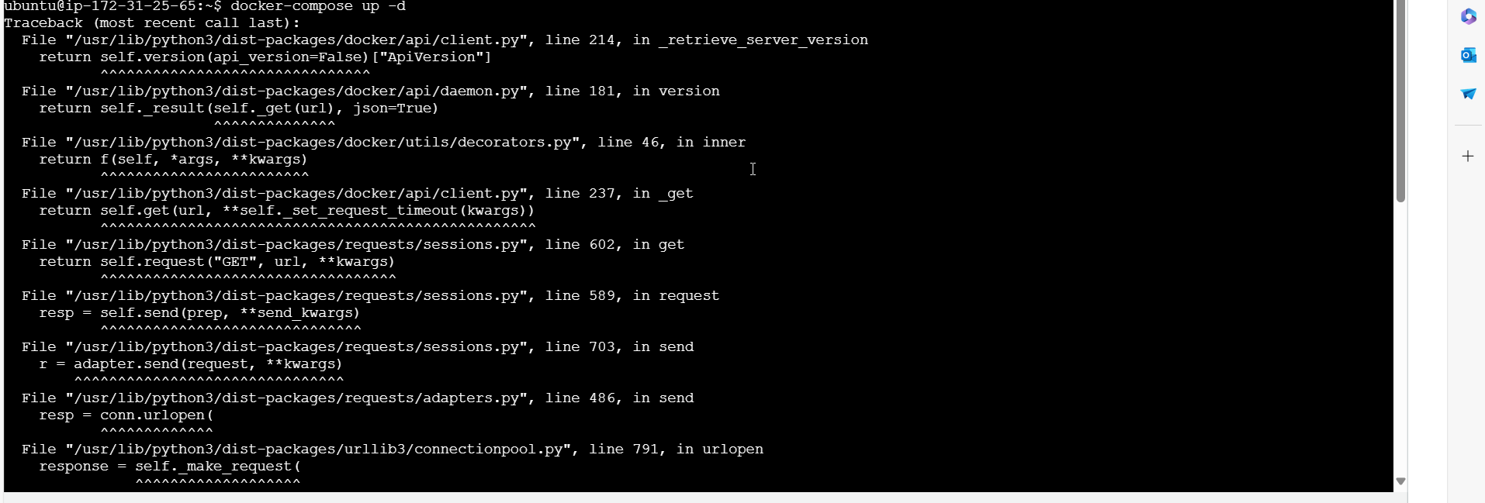

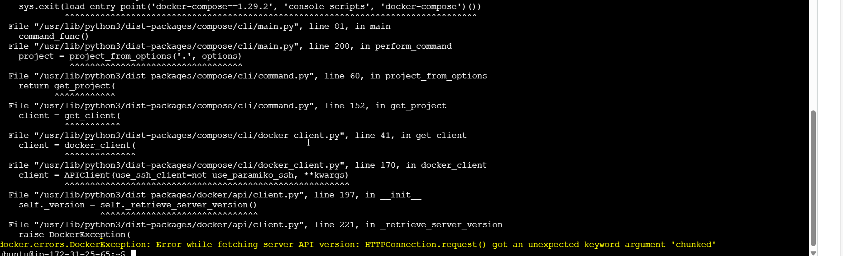

So running container using basic docker run command:

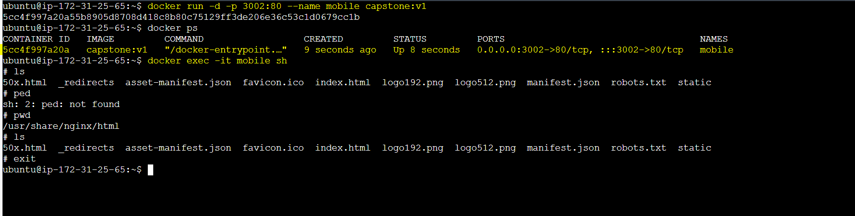

Application running in Port:3002. 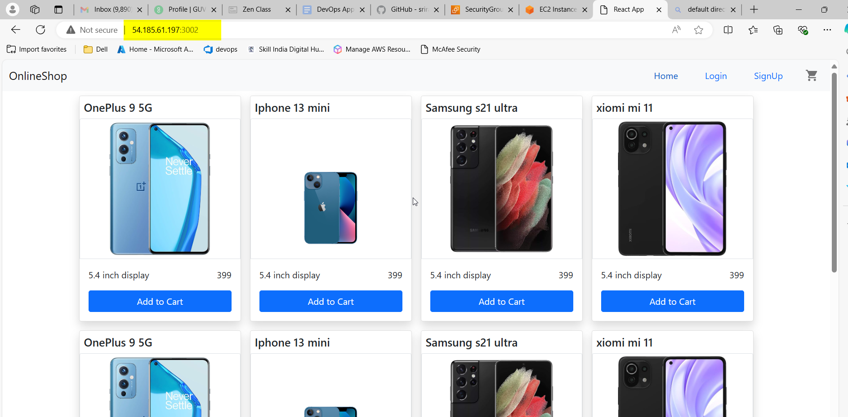

**Case 3:**

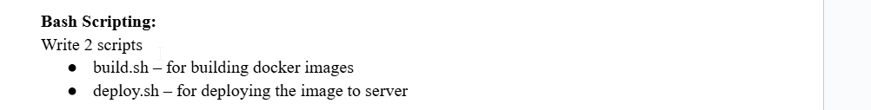

Build.sh file: 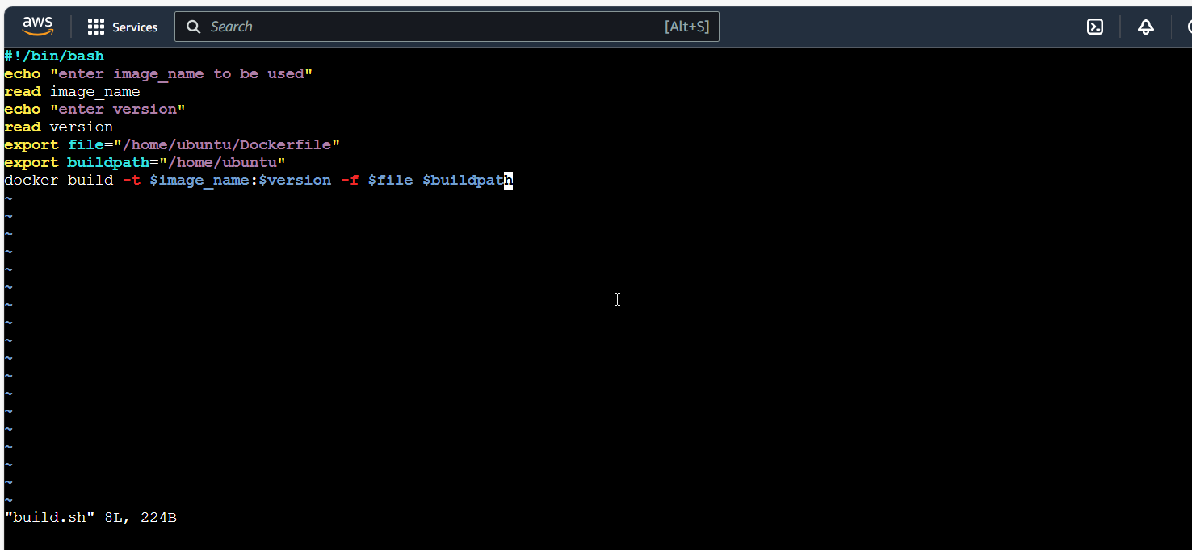

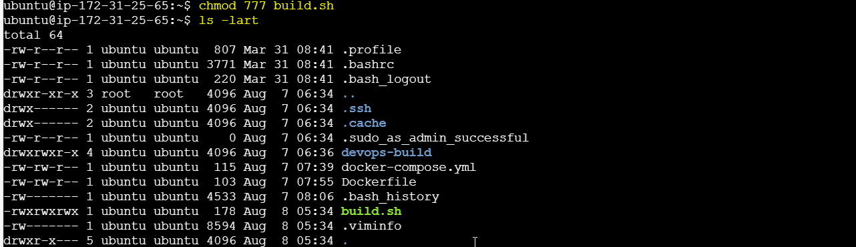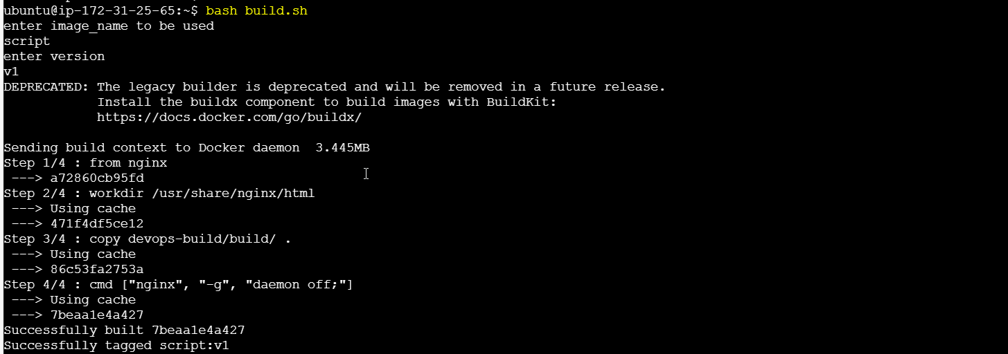

Image is built: 

**Deploy.sh:**

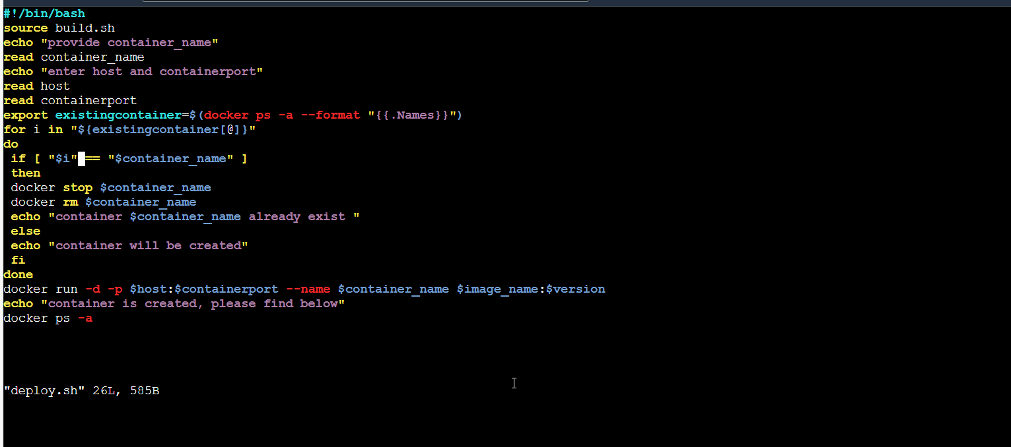

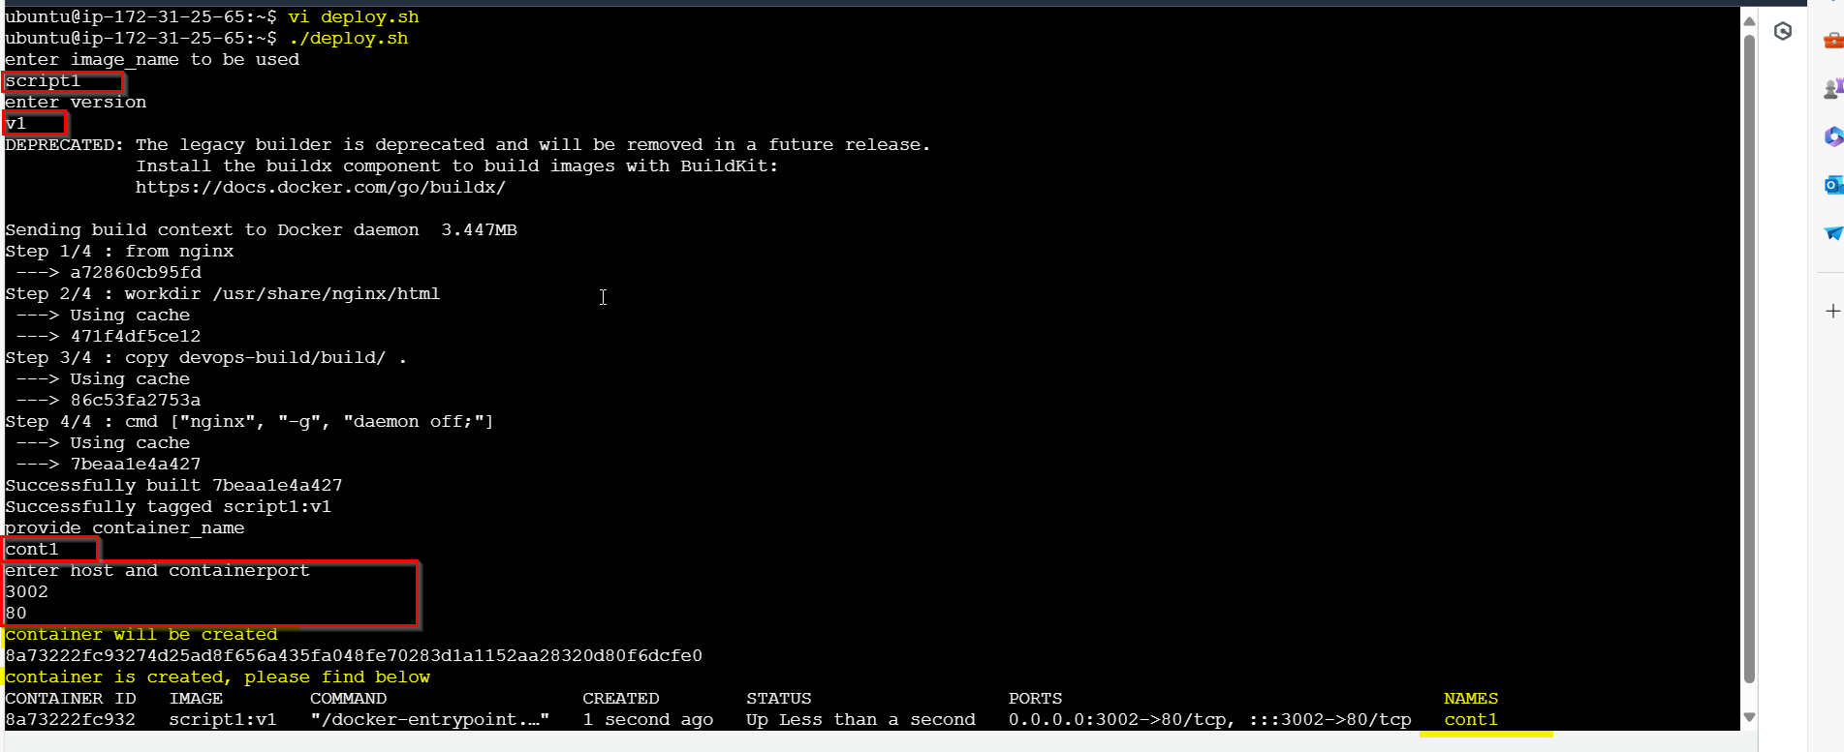

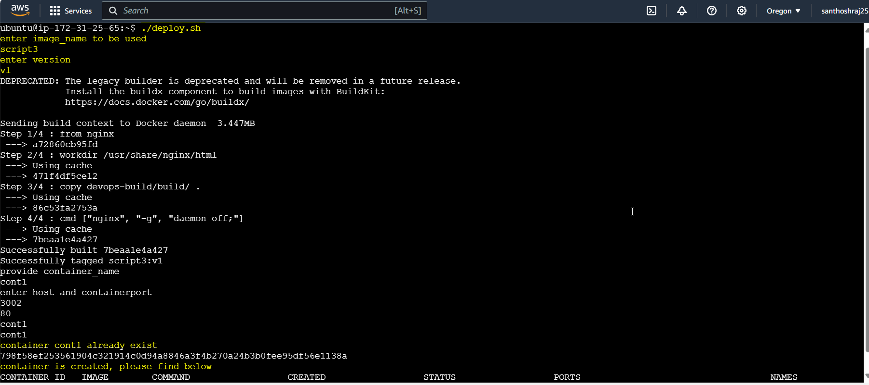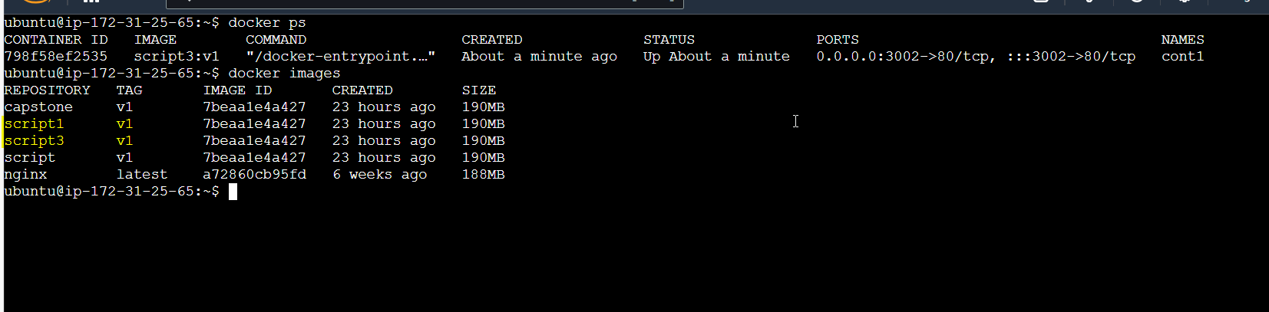

Application is running:

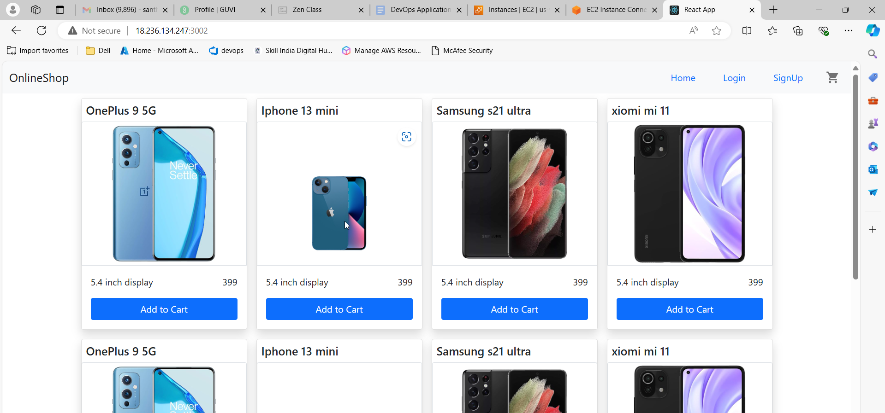

**Case4:**



Creating .gitignore and .dockerignore

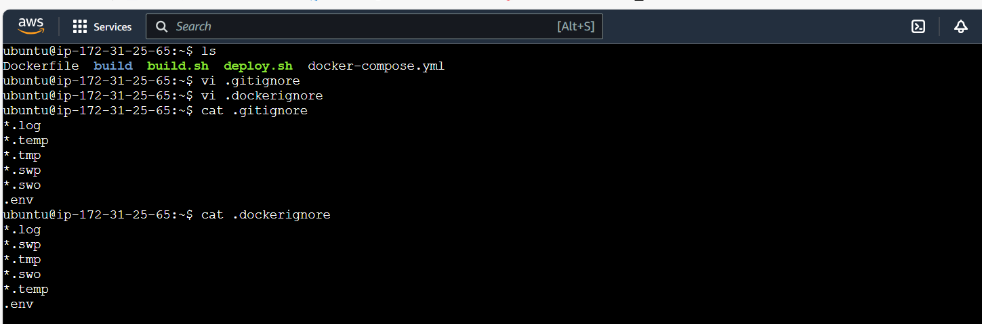

Cloning git repo:

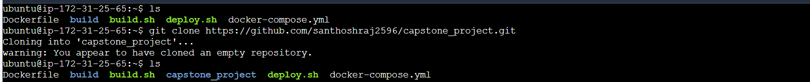

Creating dev branch:

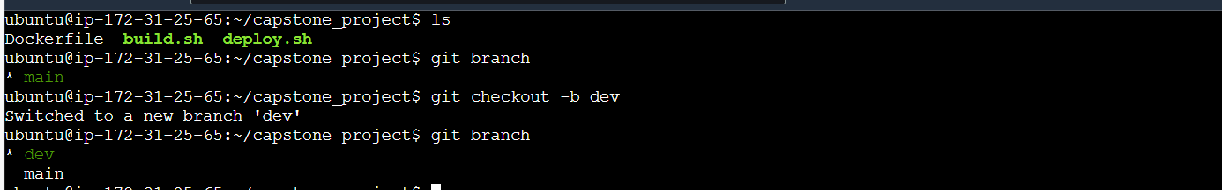

Committing changes to dev

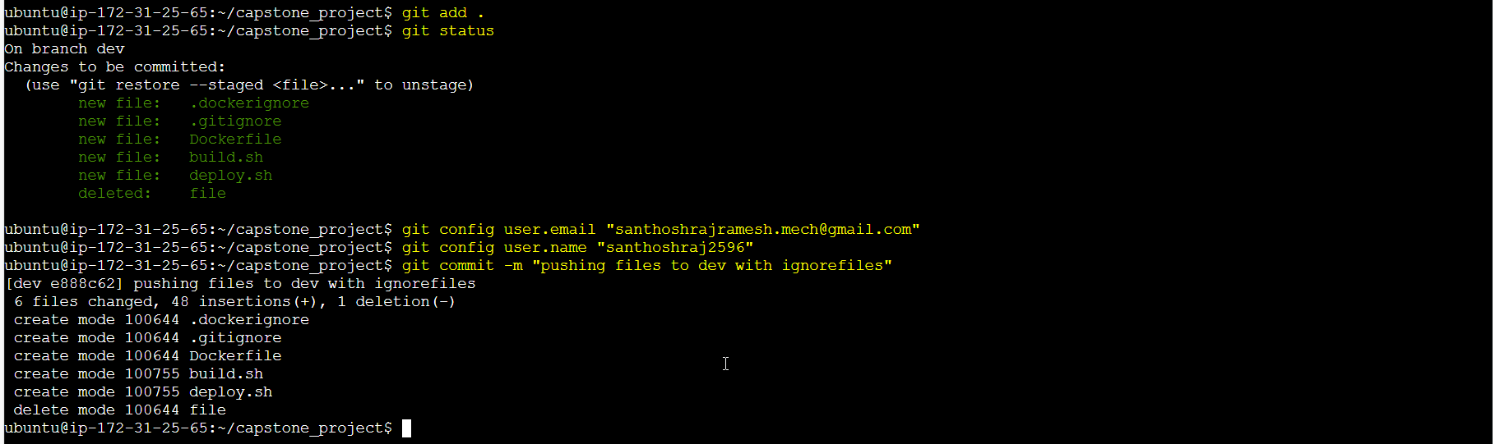

Push to dev:

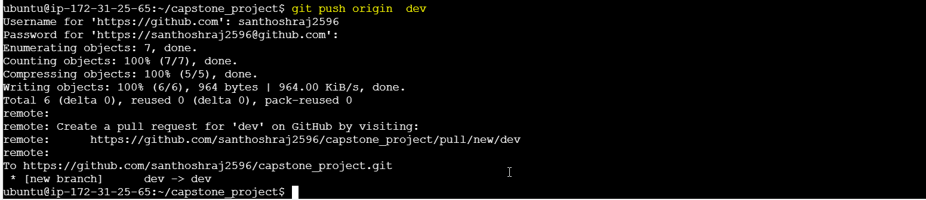

Pushed to dev branch:

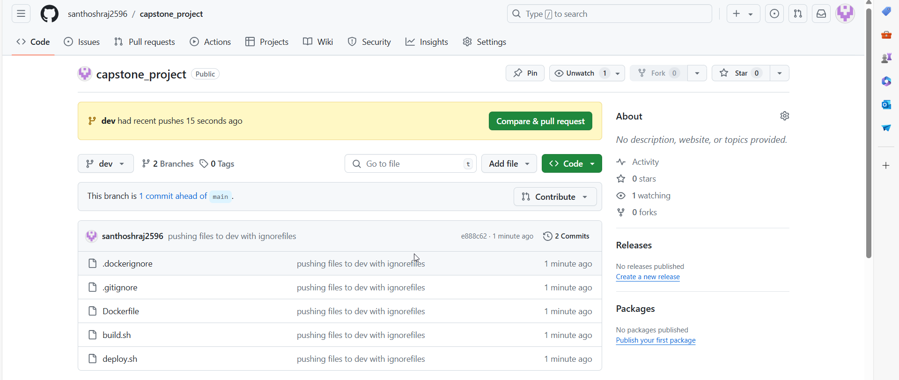

**Case 5:**



Two repository is created:

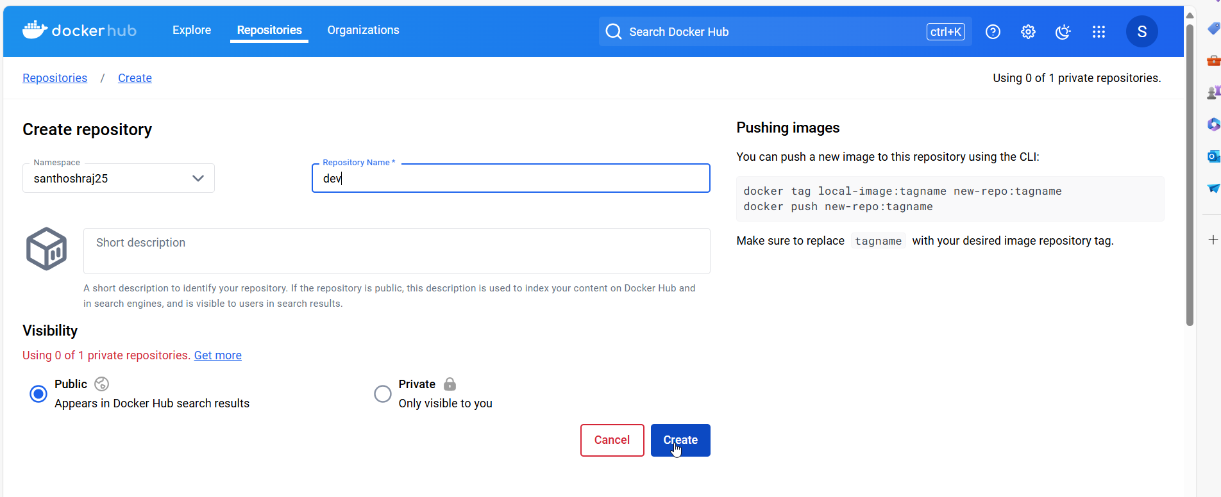

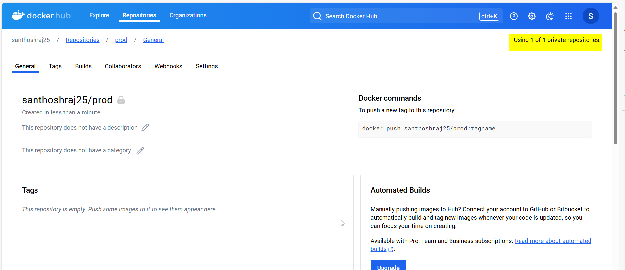

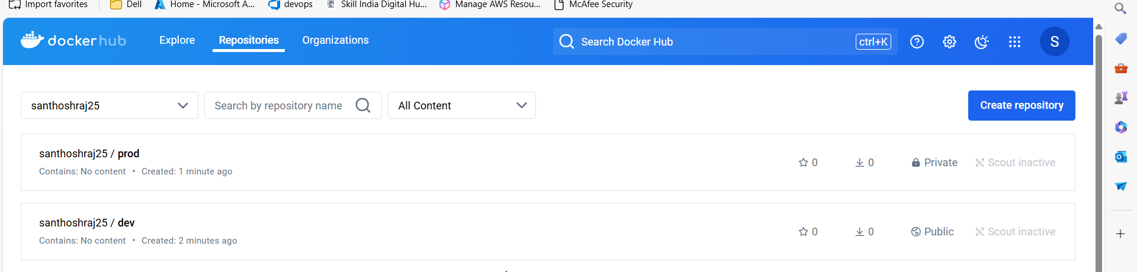

**CASE6:**

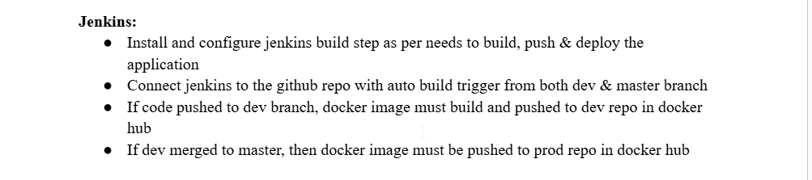

Installing jenkins using docker:

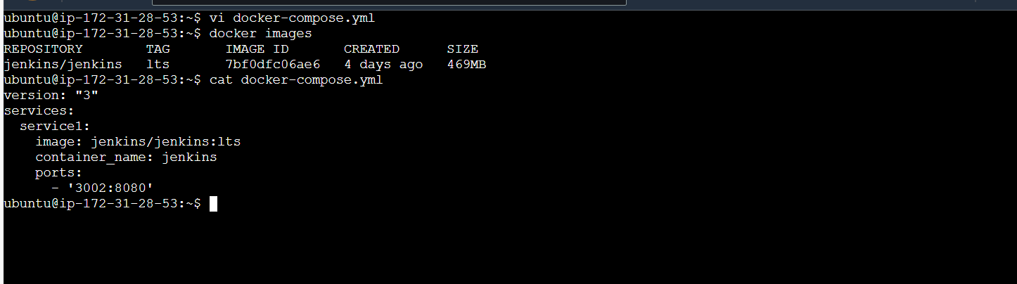

Due to API server issue, cant able to run the container using docker-compose:

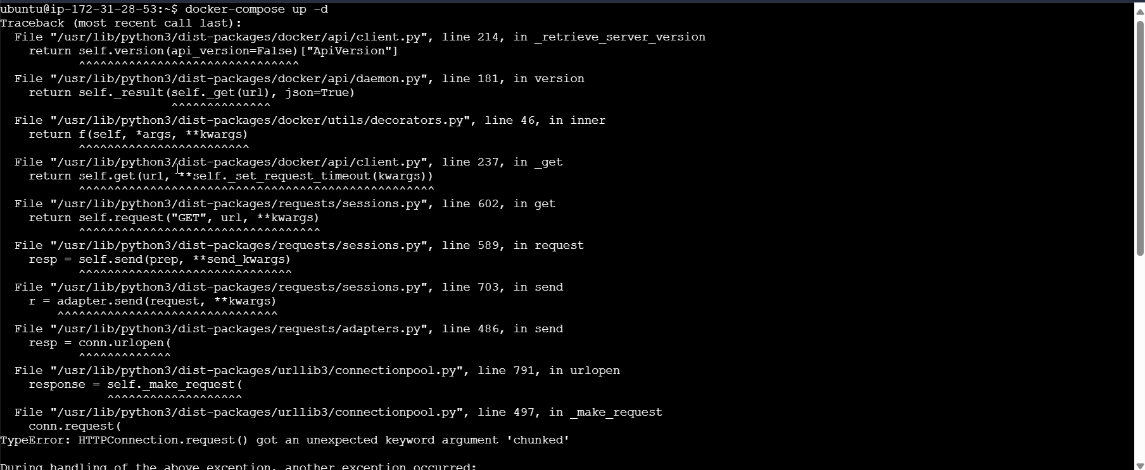

Using docker run :

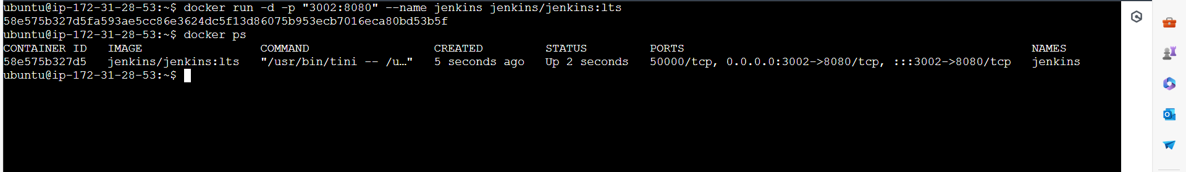

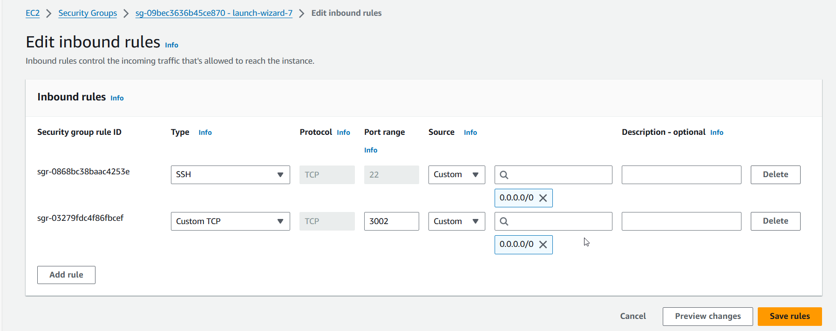

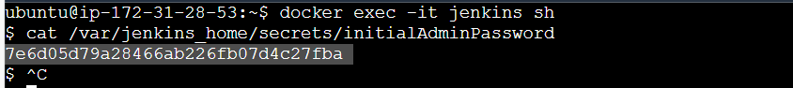

Jenkins:

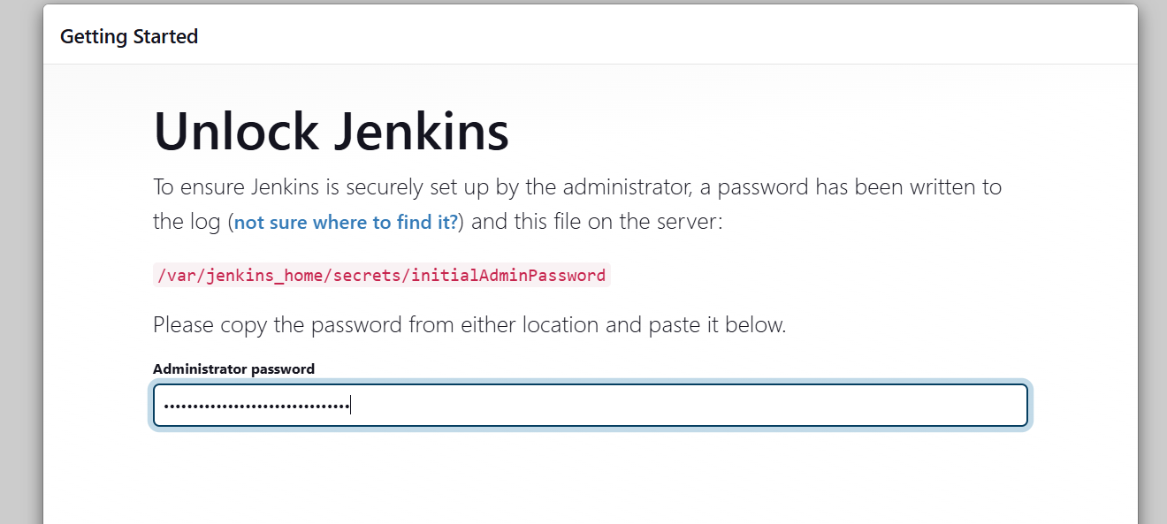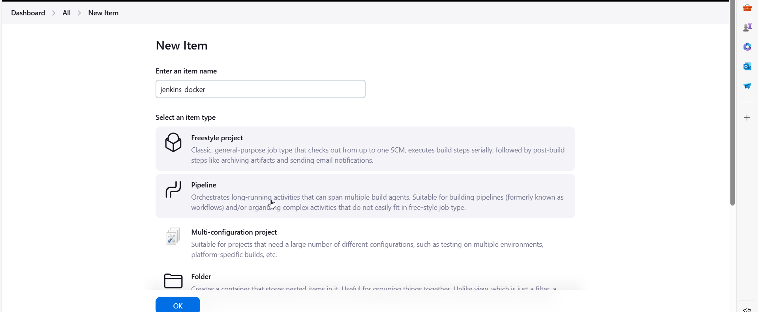

Steps to build docker image and push to docker hub:

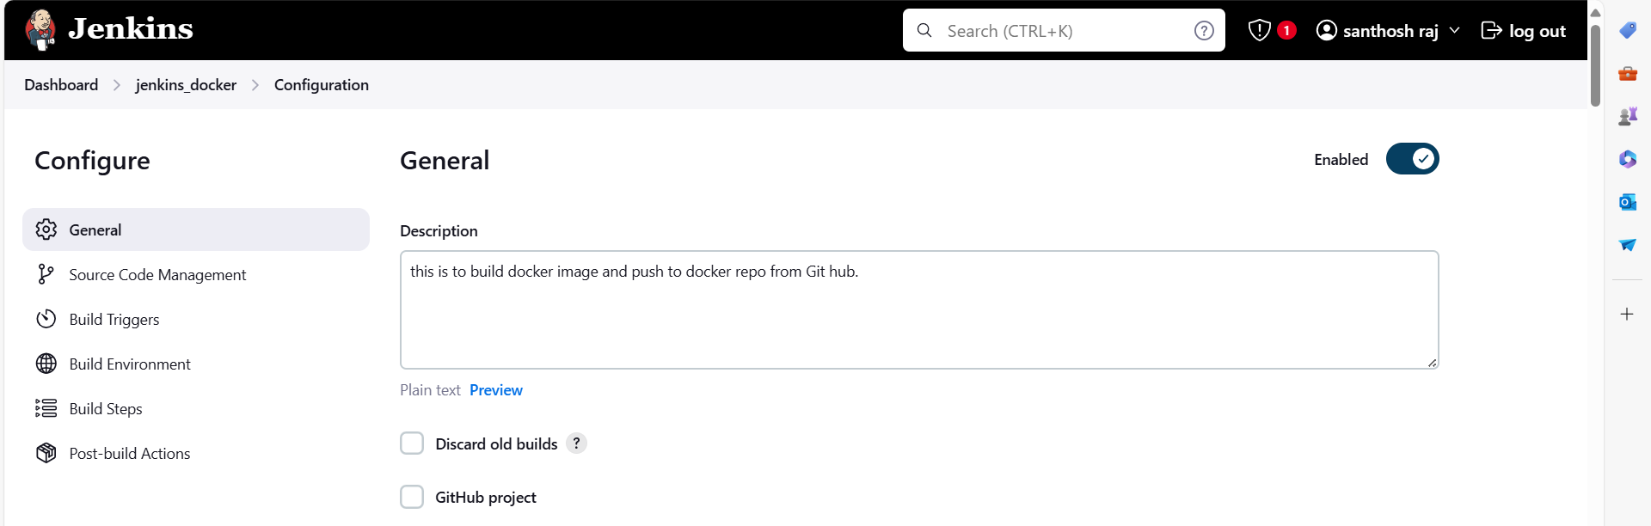 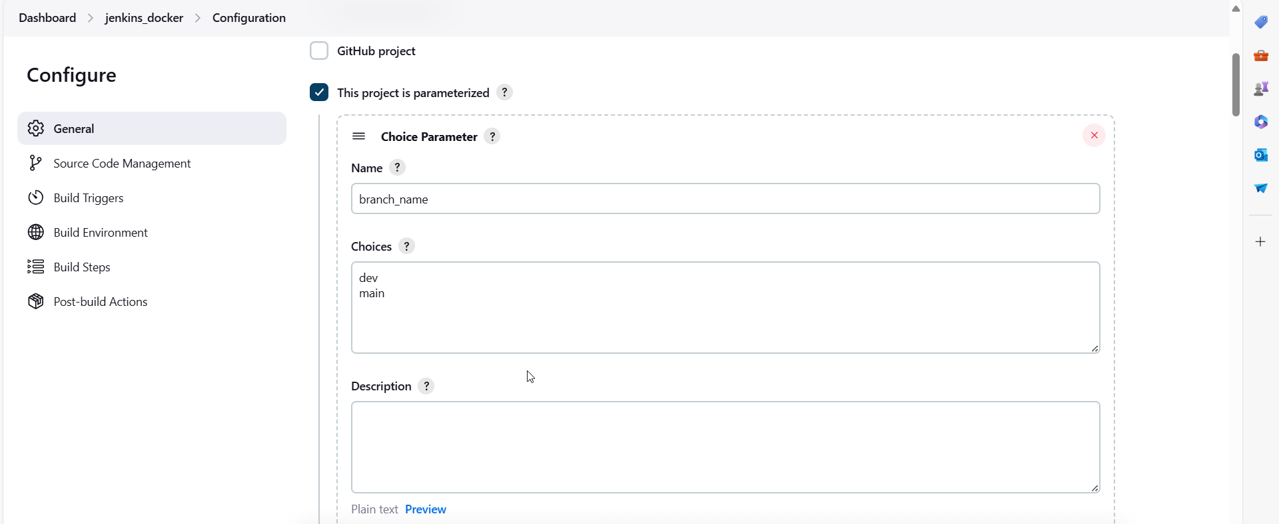 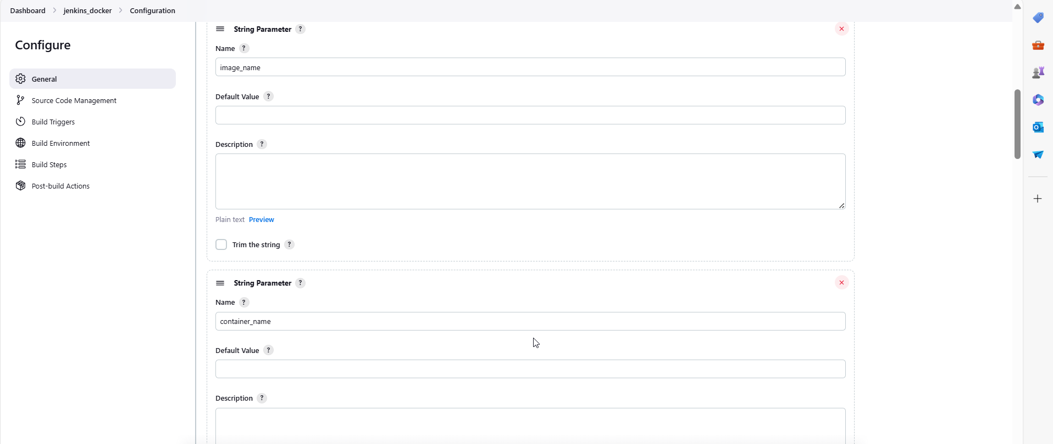 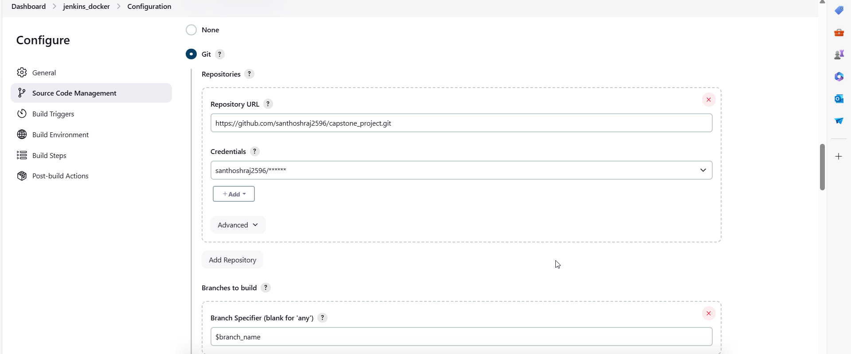

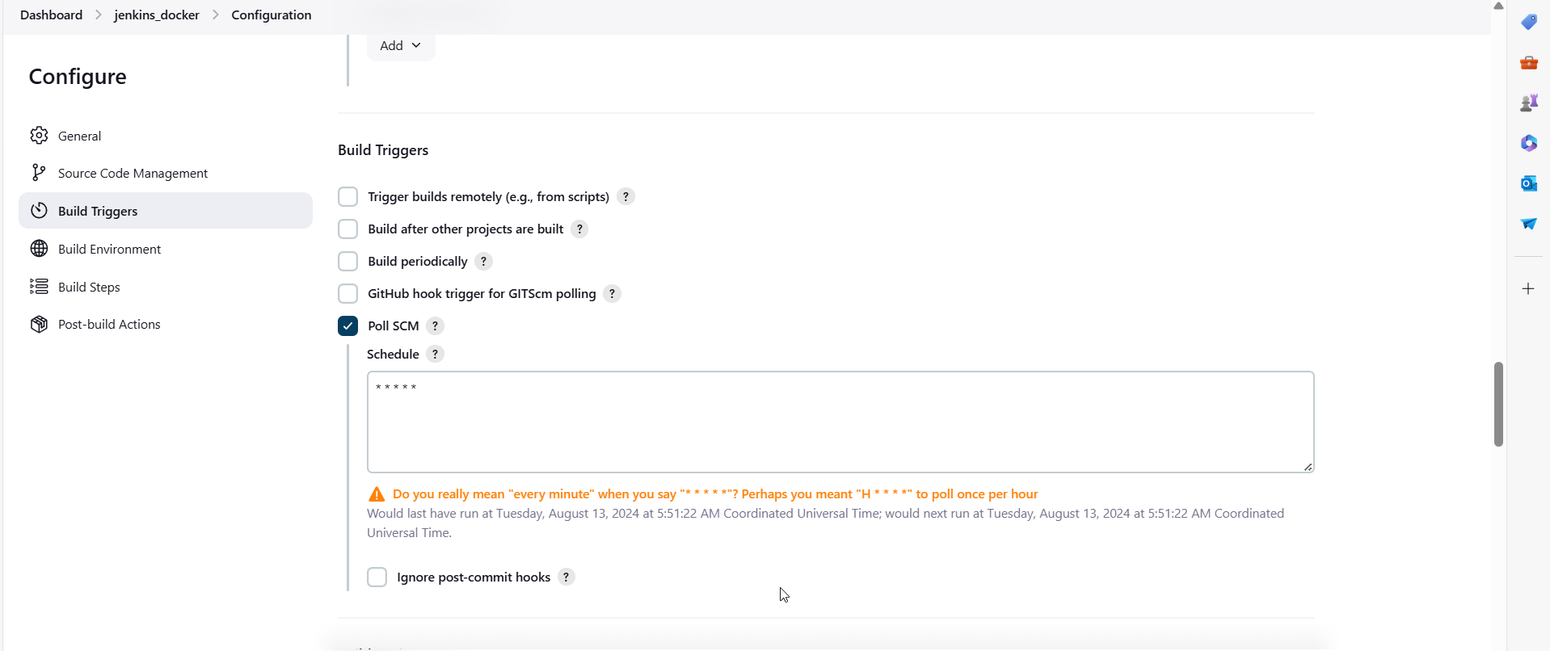

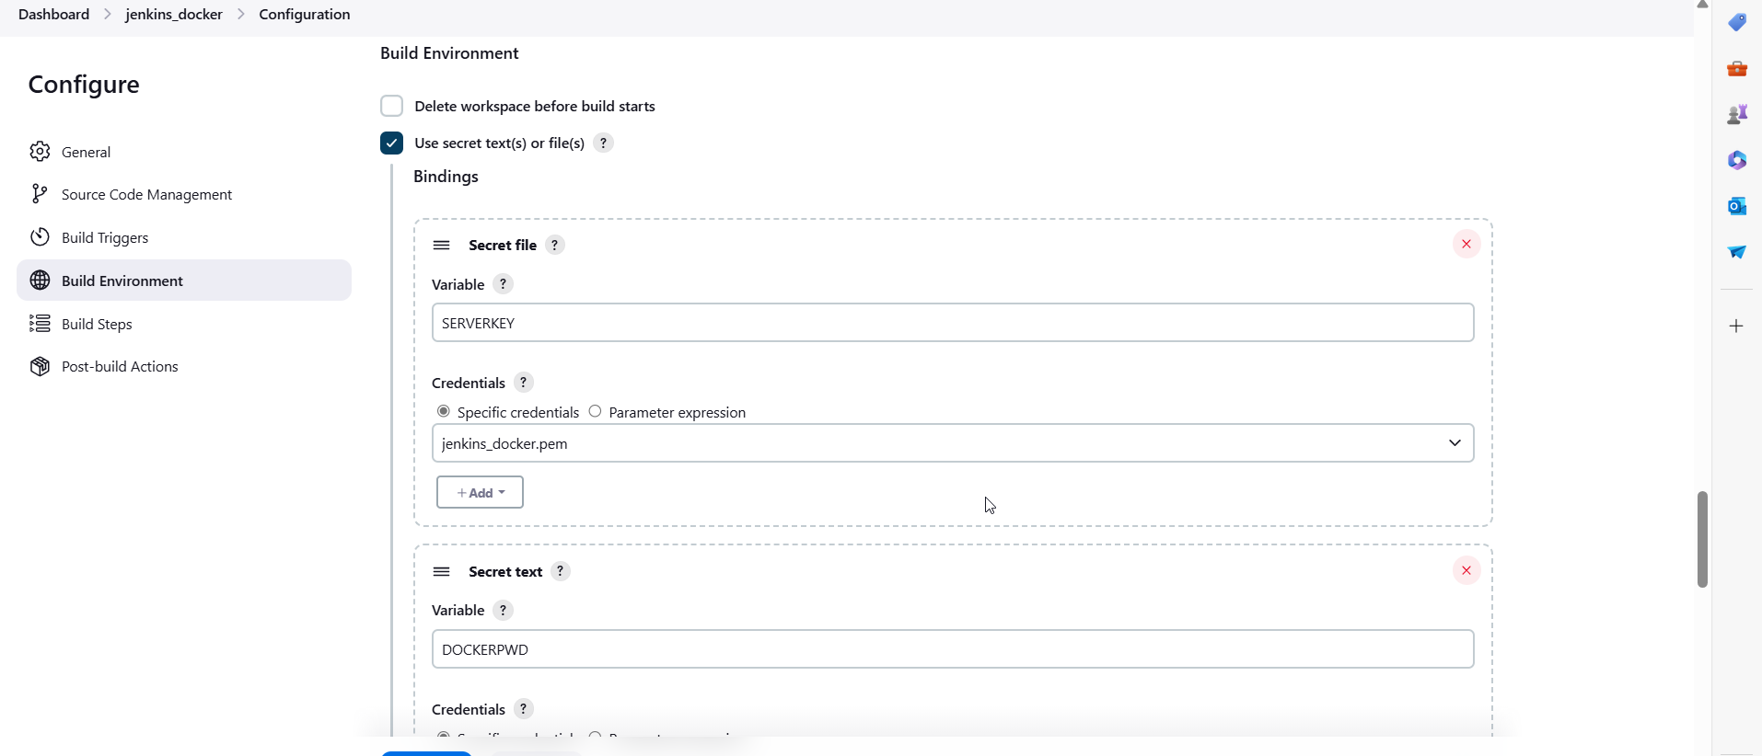 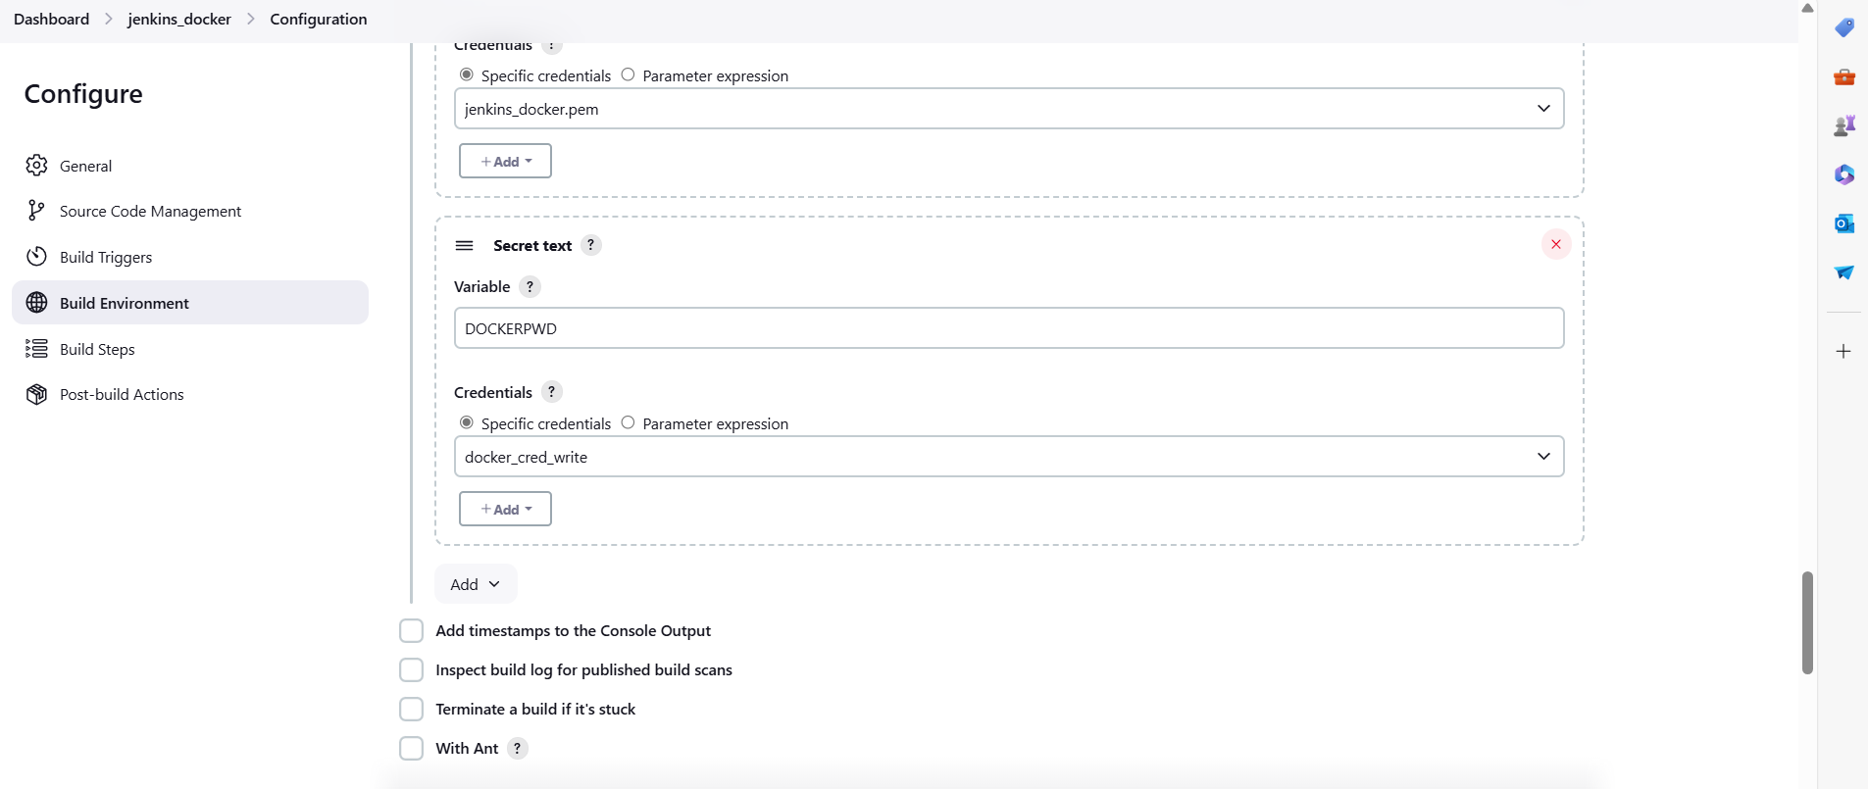 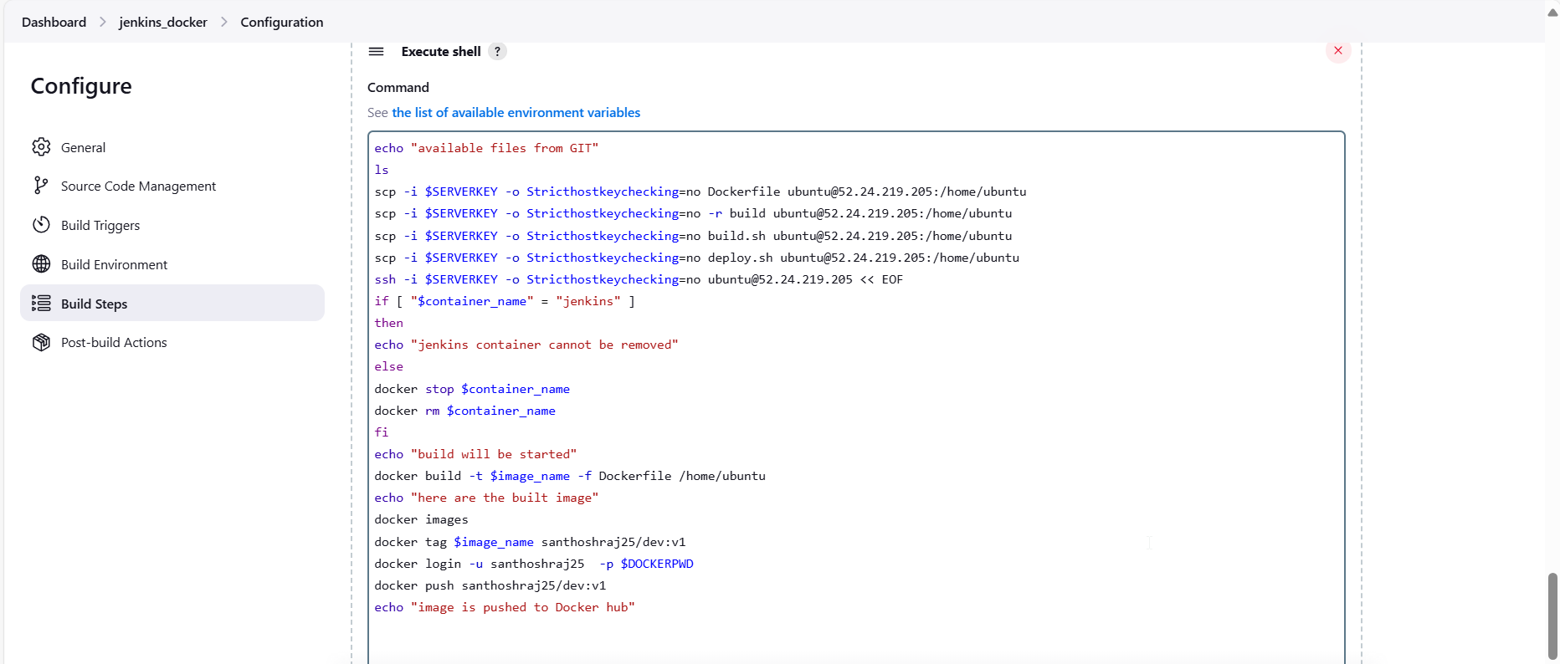

**Script:-> execute shell script:**



Committing changes in GIT hub in dev branch:

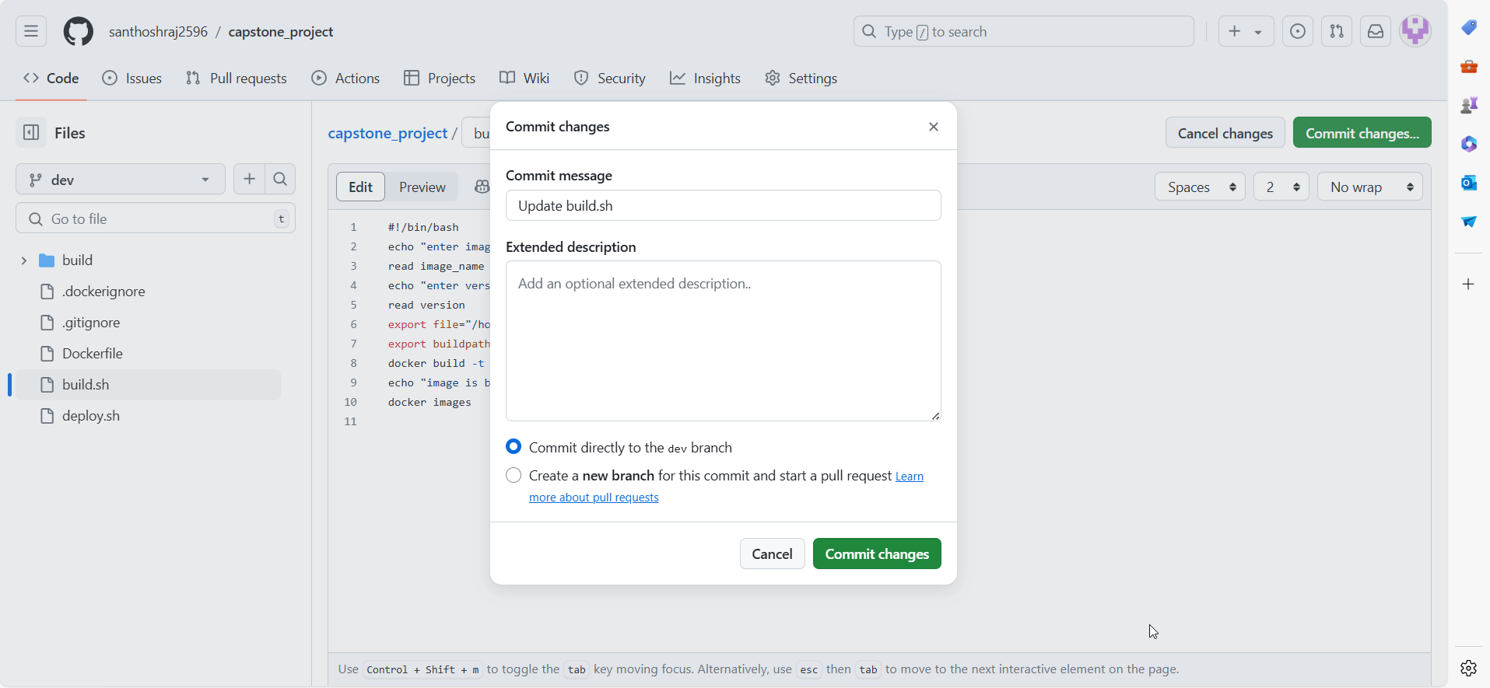

Within minute image is pushed to dockerhub by POLSCM:

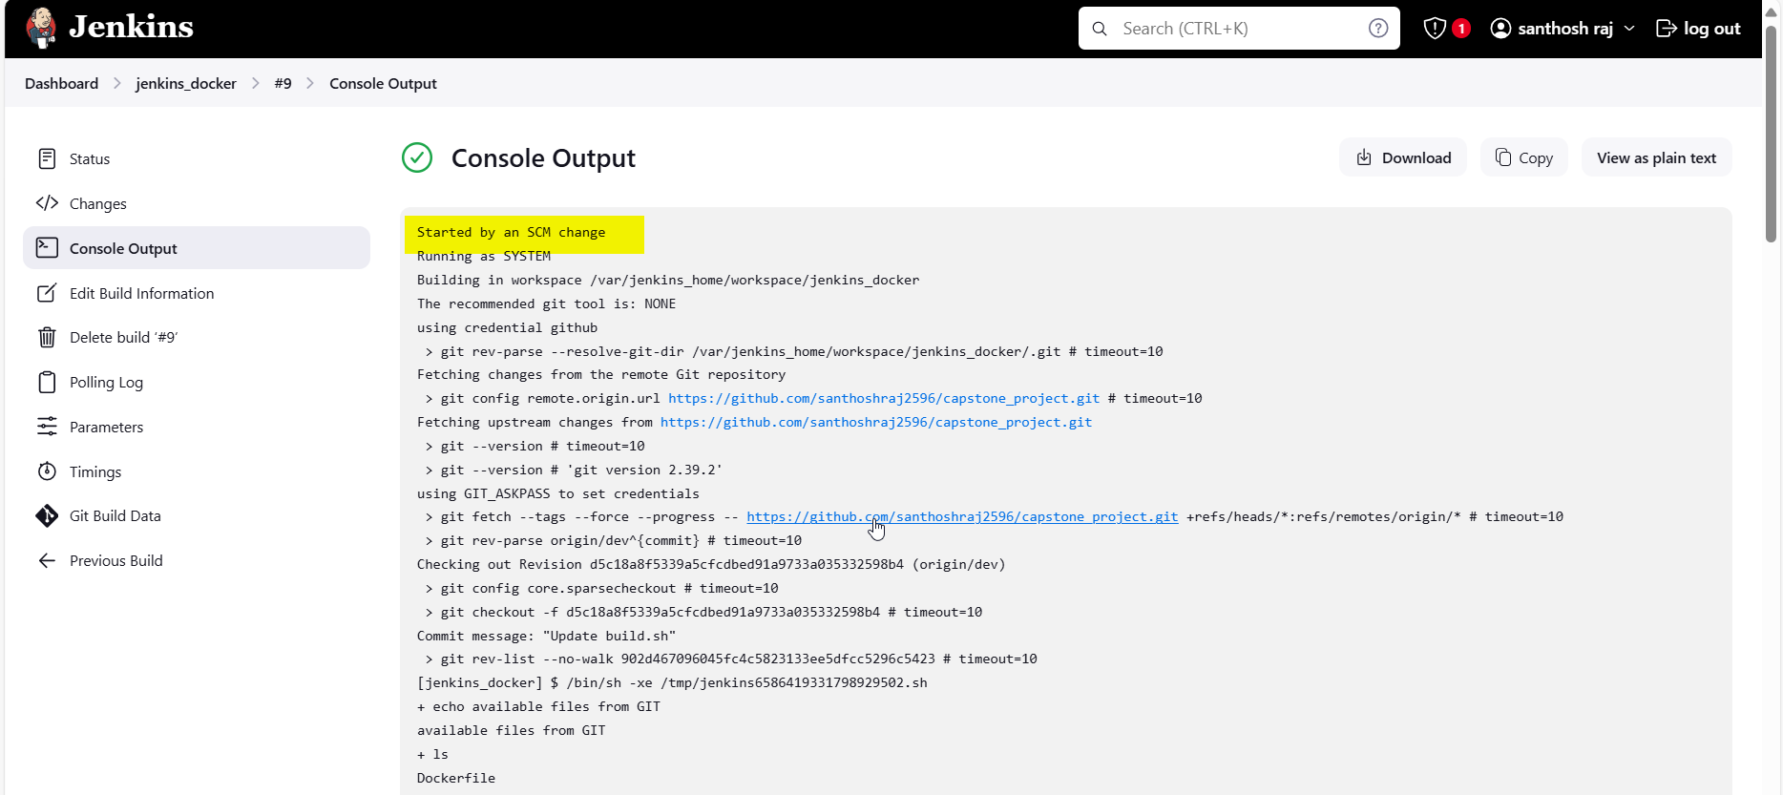

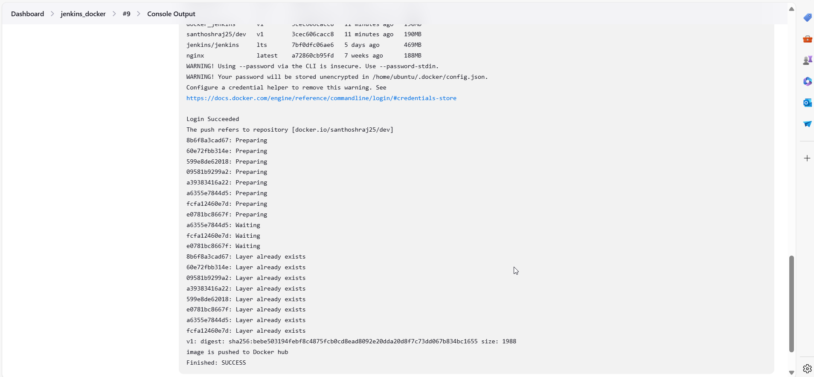

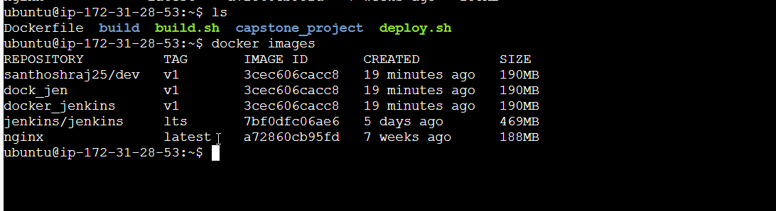

Image in Dockerhub in Dev repo:

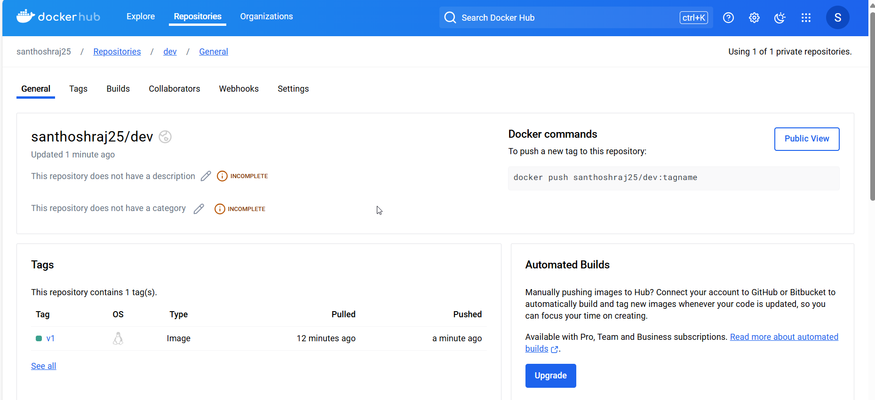

Building job for Master branch: with same procedure 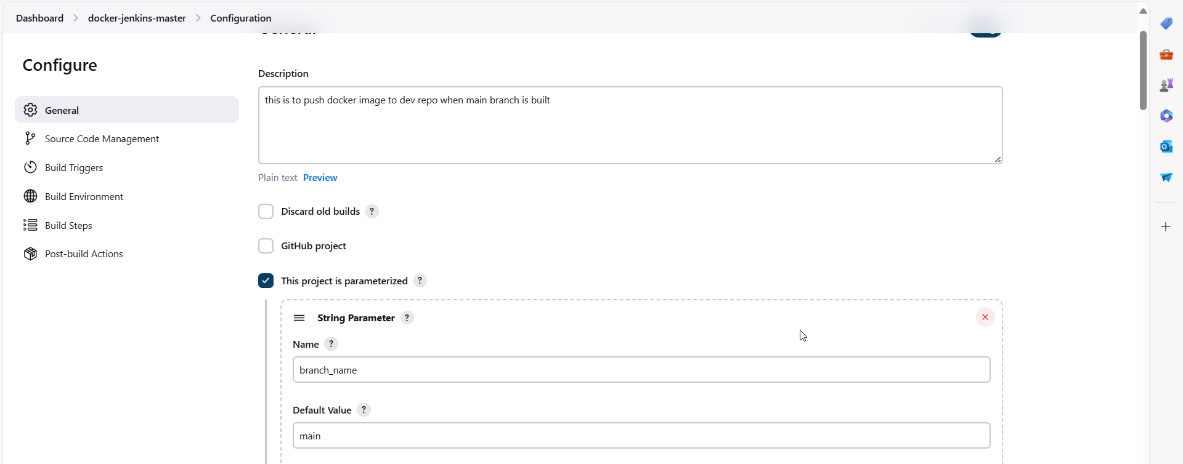

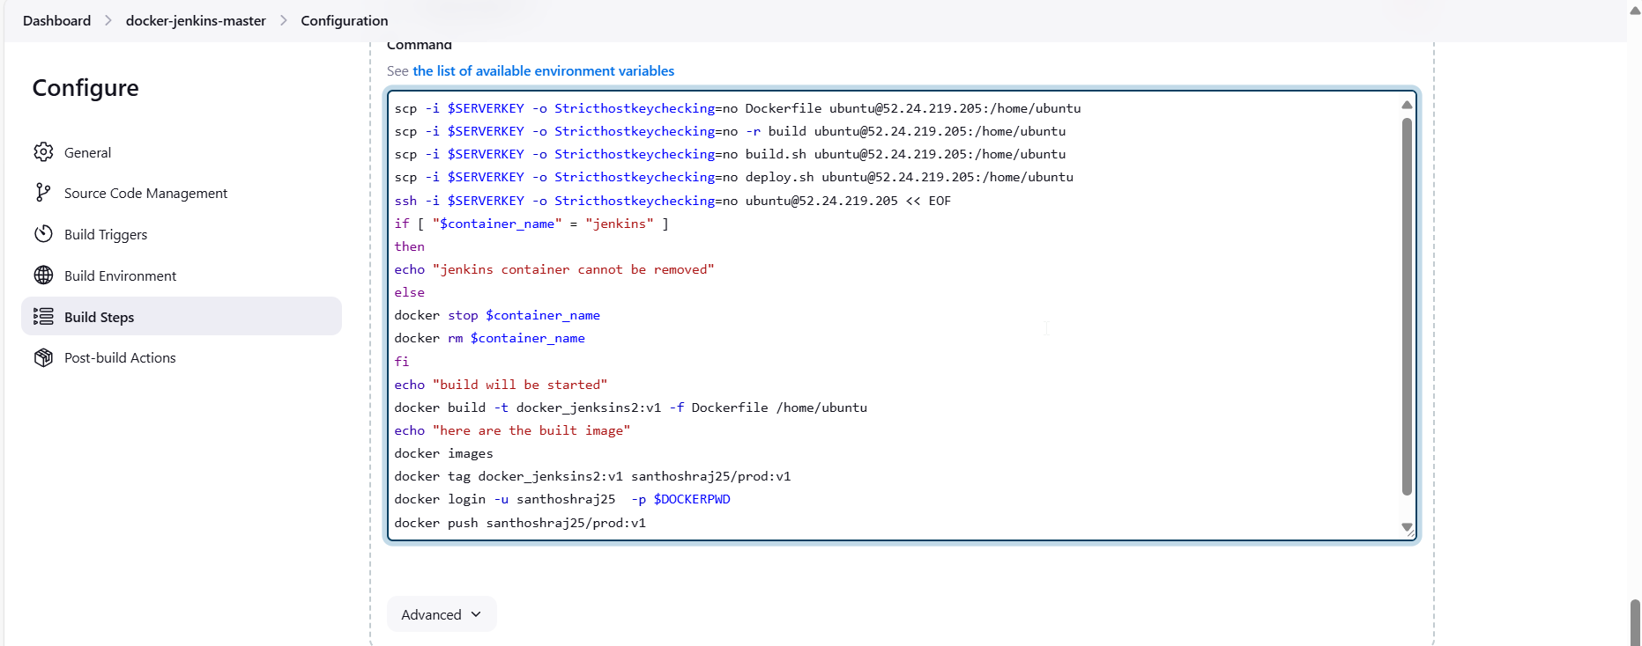

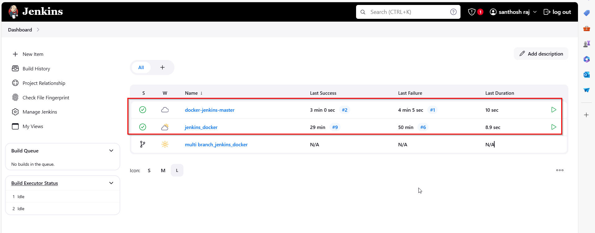

**Merging changes to main from dev in Github:**

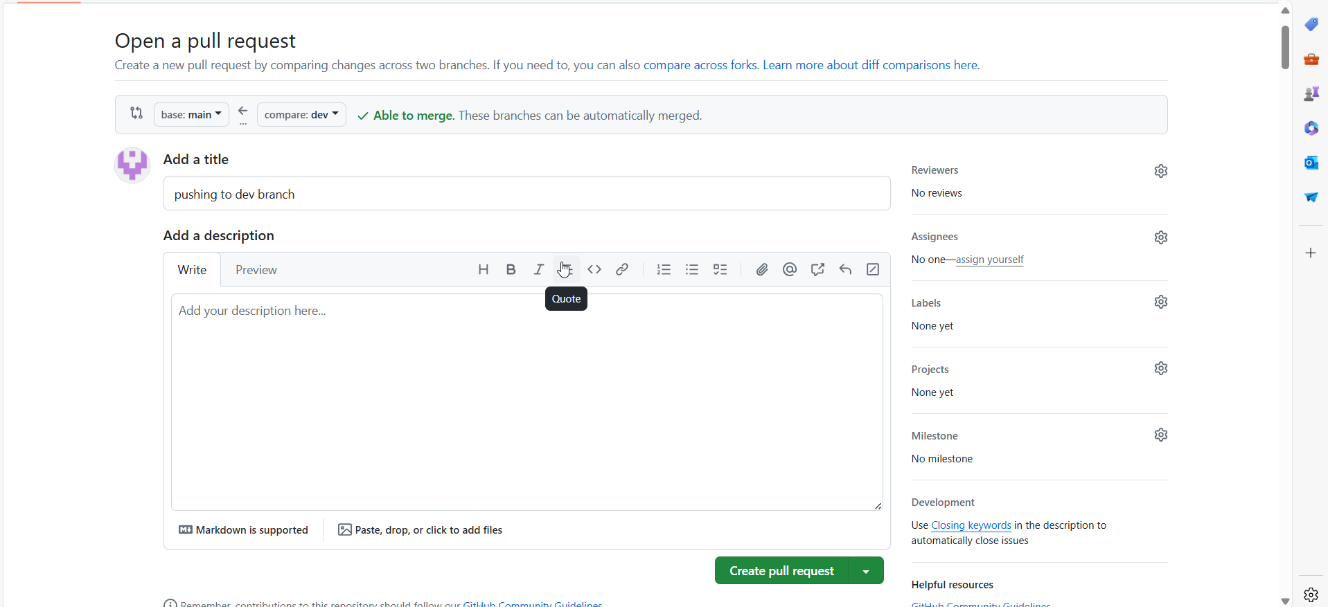 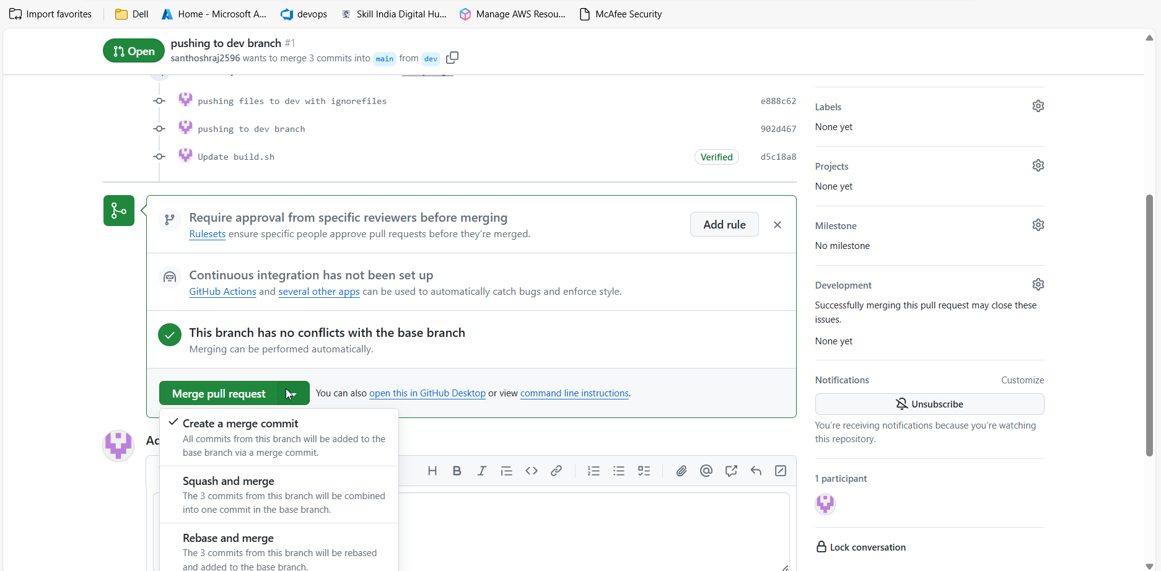 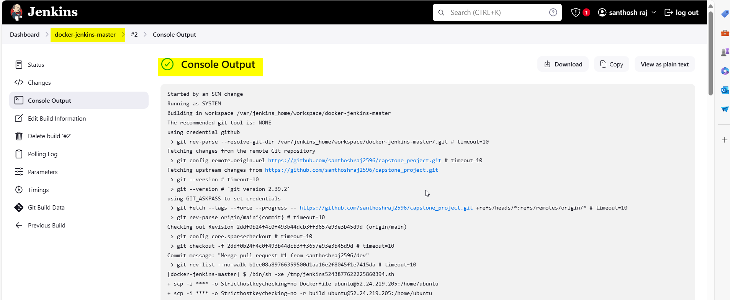 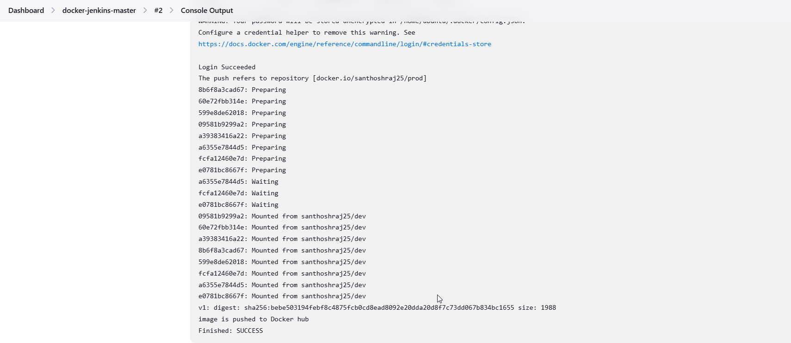

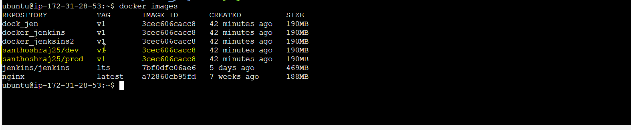

Image is pushed to prod repo in docker hub:

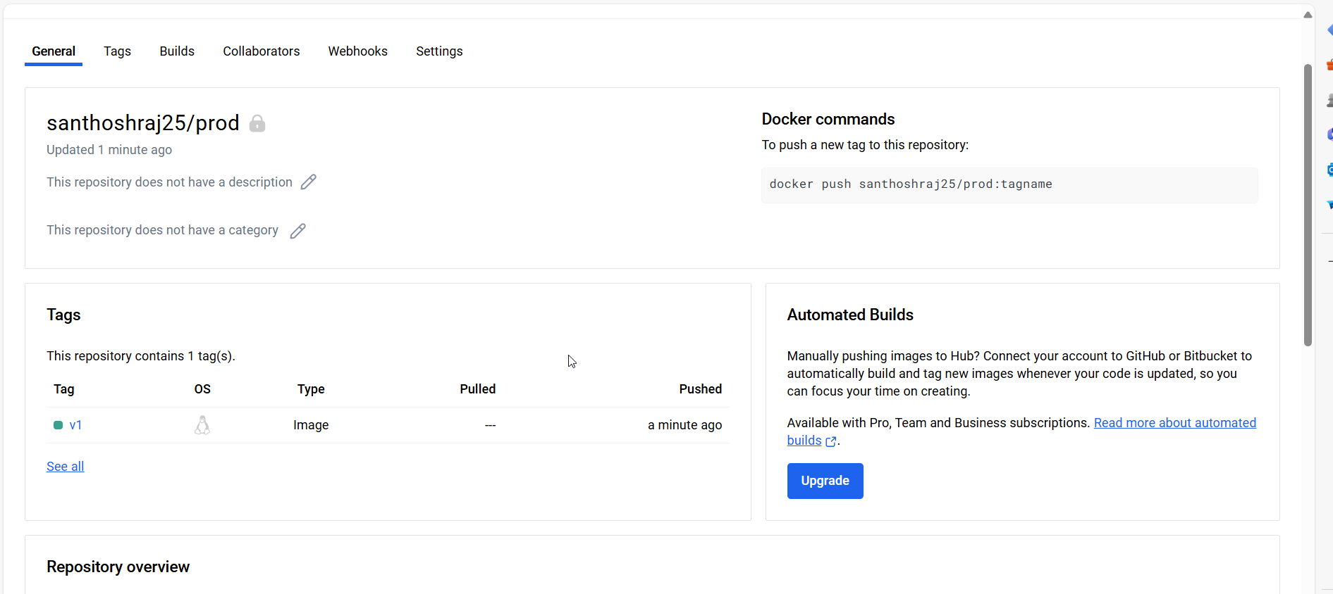

**CASE:7:**

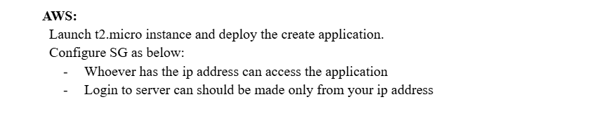

Creating EC2 instance:

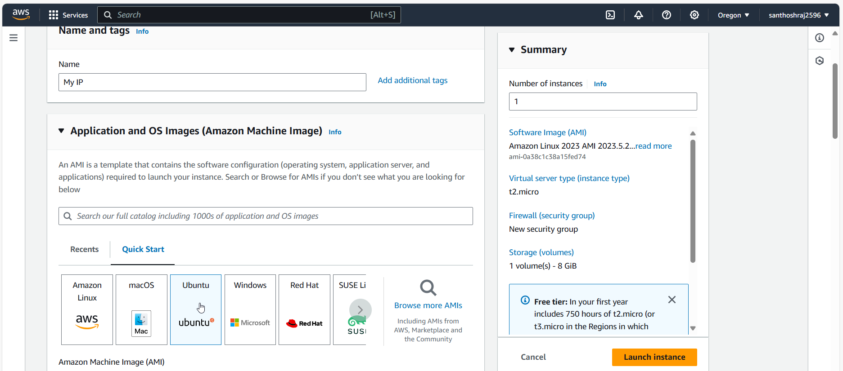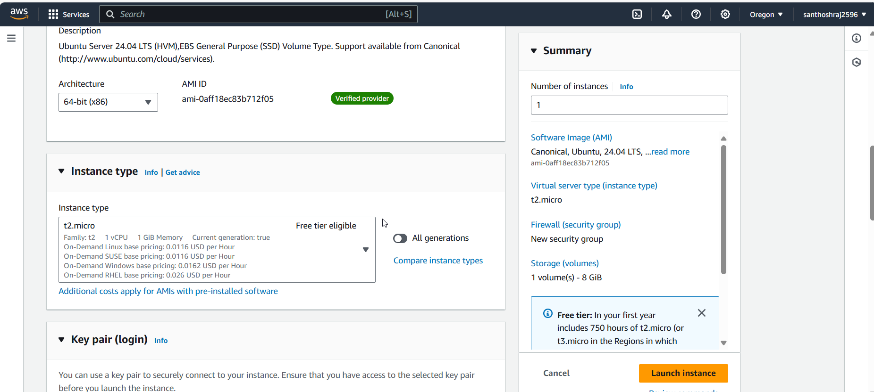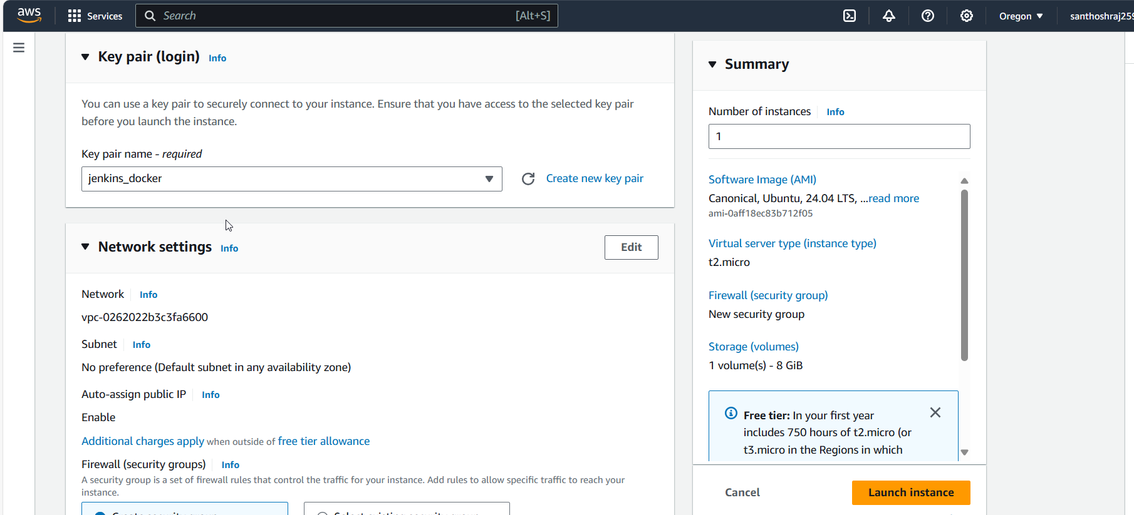

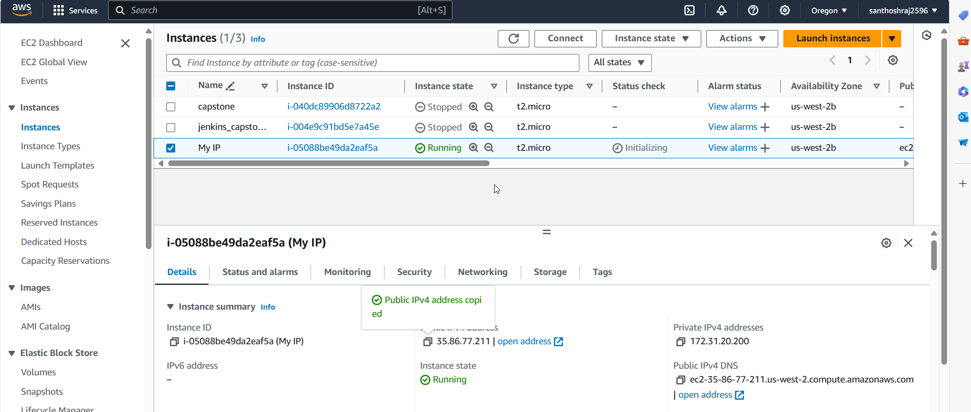

**Configuring Security group:**

SSH-> only My IP

Custom TCP-> those who have IPV4 address with port 80 can access my application.

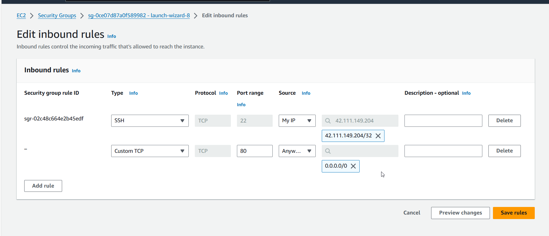

Cant able to directly login: since SSH is mentioned as MY IP.

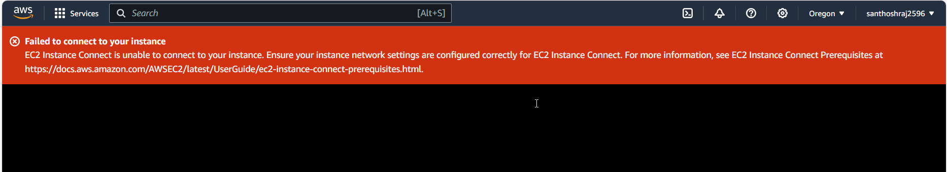

Using SSH from local (My IP):

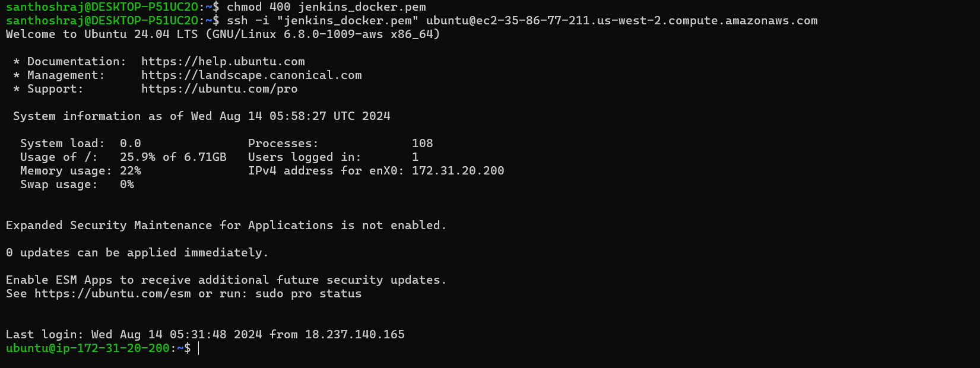

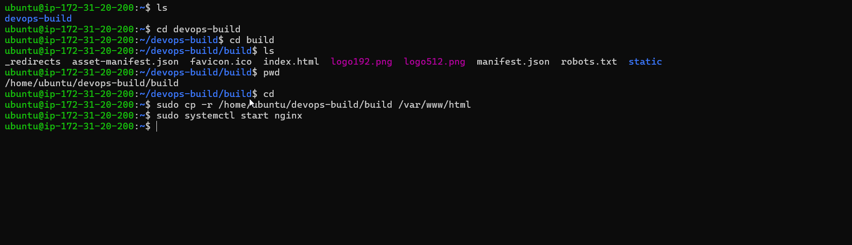

My application is running in port 80, using EC2 public IP.

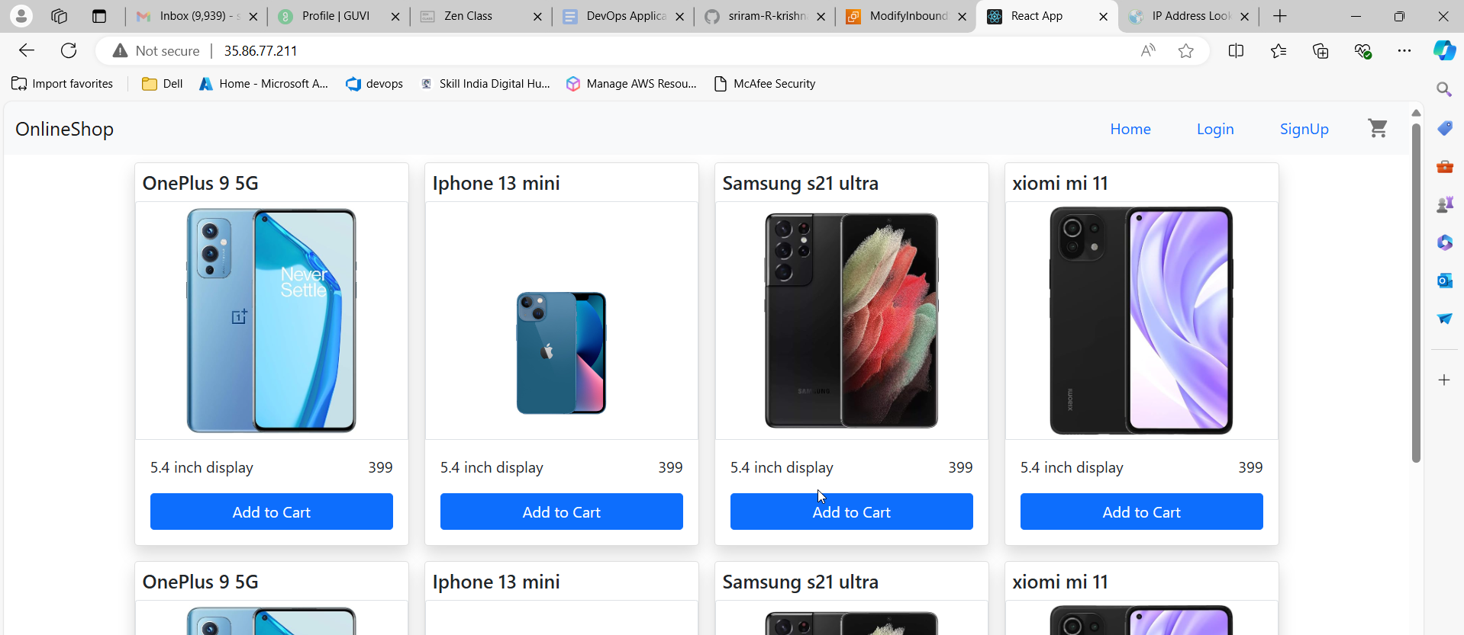

**Case 8:**

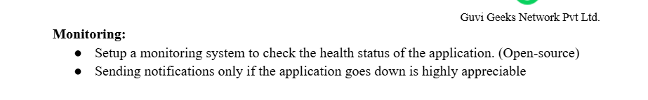

Creating two instance:

1. App-monitoring (monitoring server)

2. Application(to be monitored server)

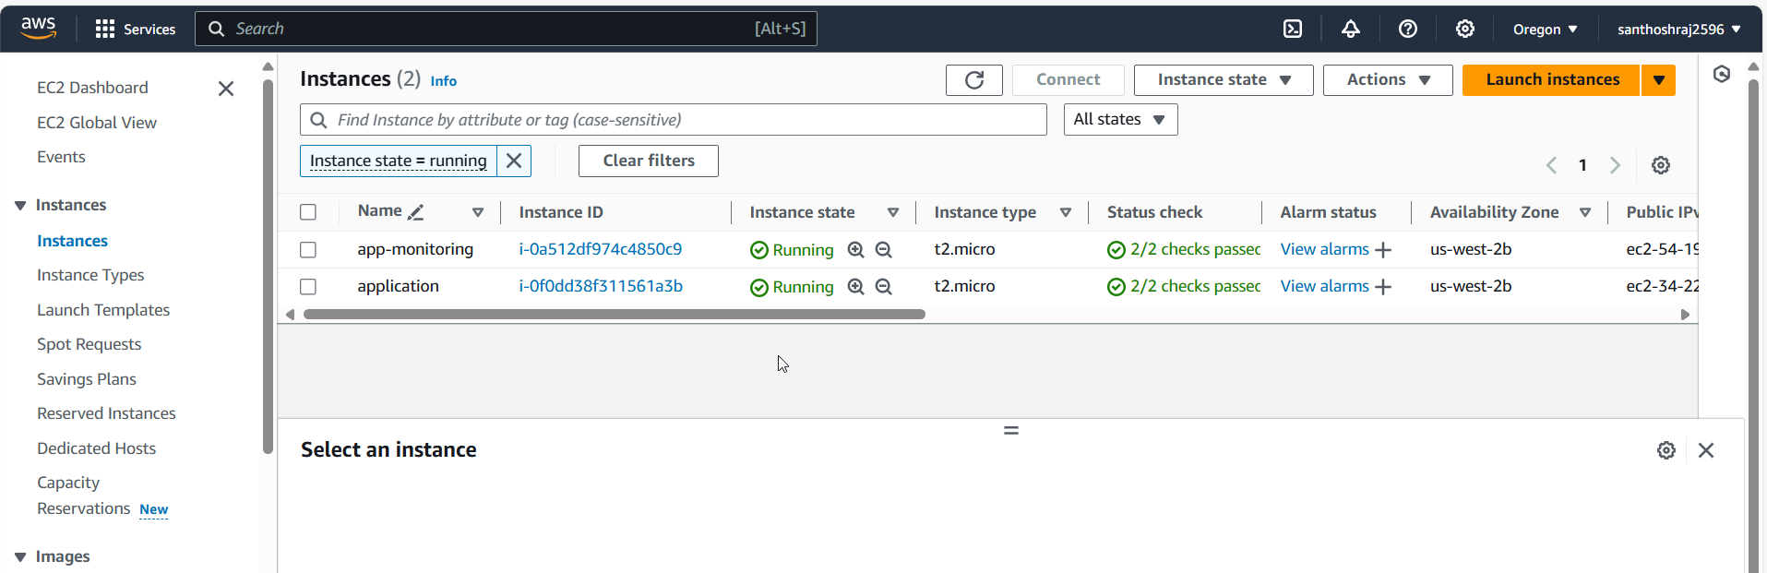

Installing prometheus and grafana in App-monitoring server:

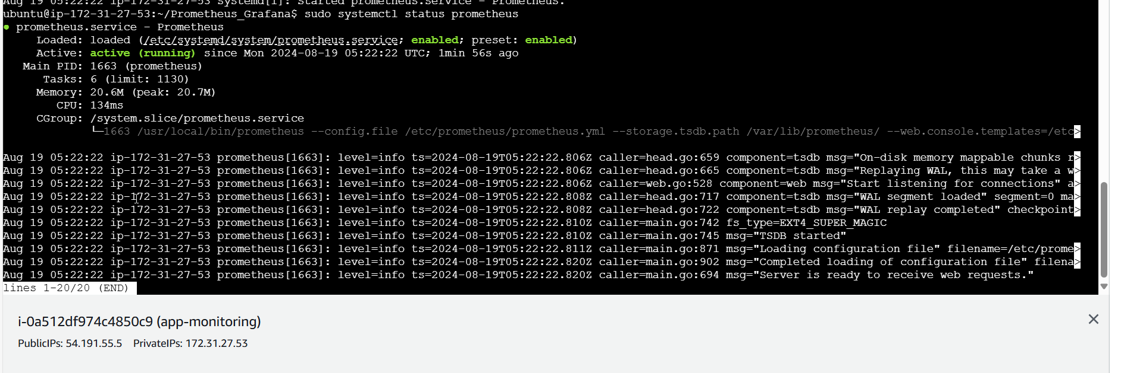 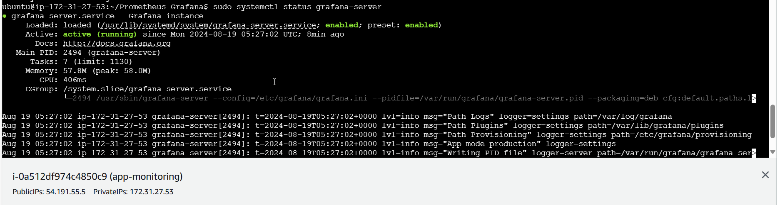

Allowing incoming traffic in inbound Security group (App monitoring):

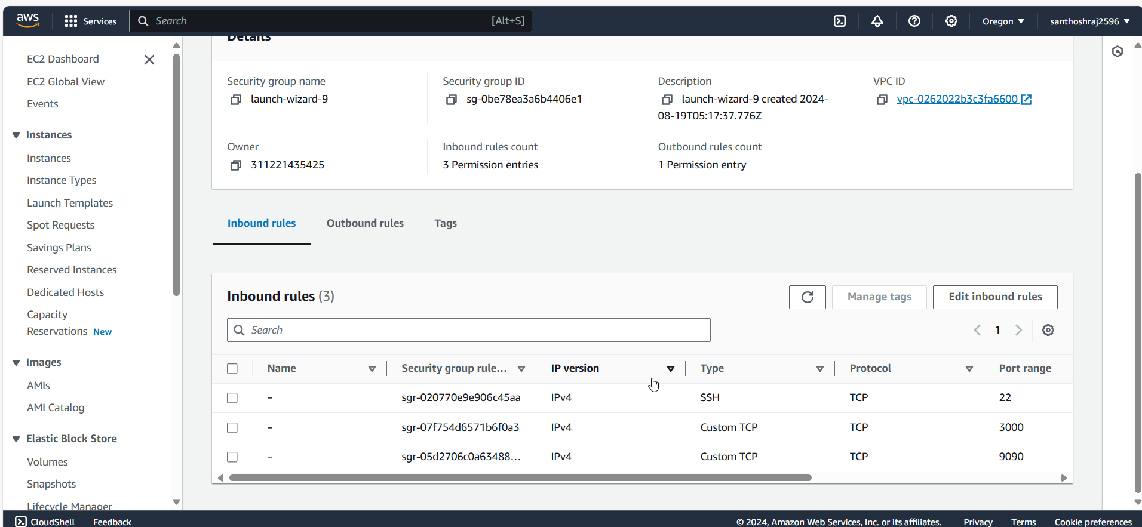

Installing **node-exporter in Application server**:

So it will communicate with prometheus in App-monitoring server.

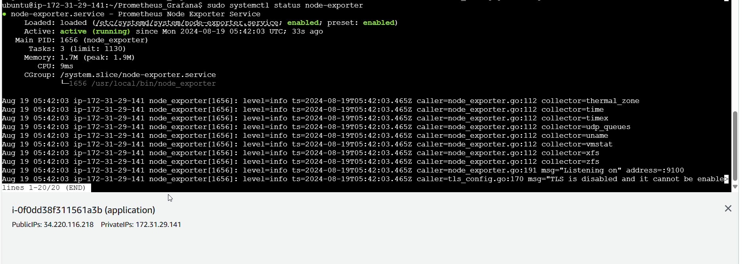

Allowing traffic in SG(application server):

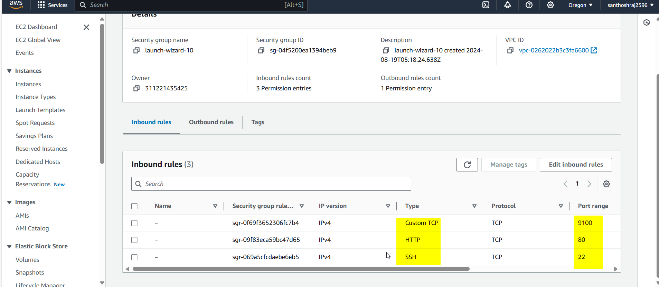

Adding node exporter (target) to prometheus.yml configuration file in App-monitoring server,

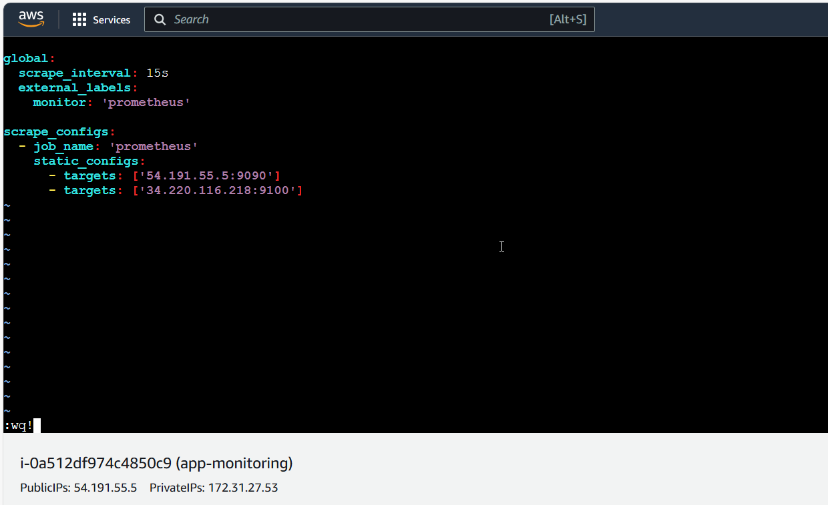

Prometheus and node exporter is running fine:

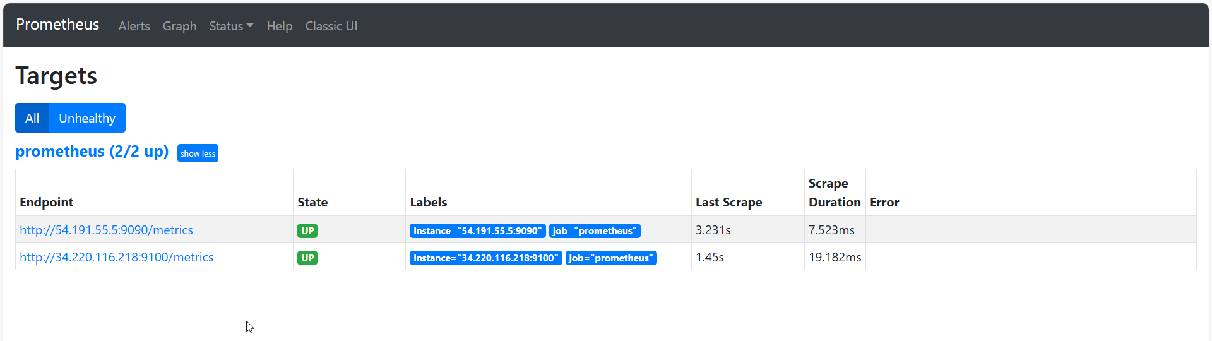 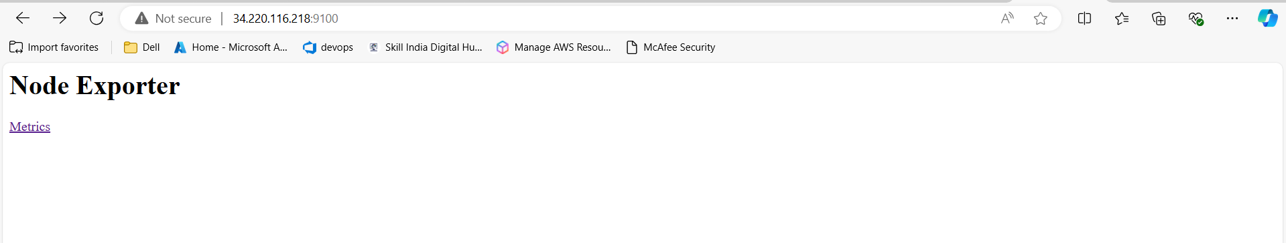

Adding Datasource in grafana:

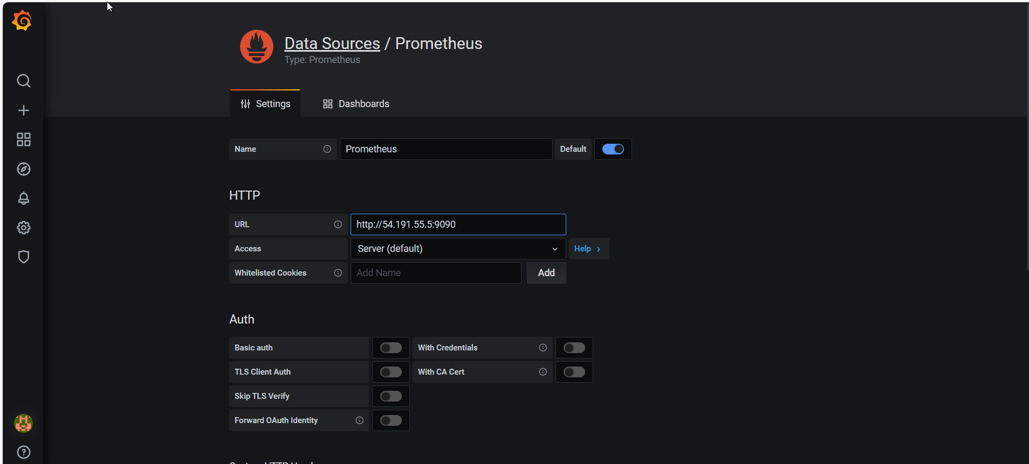

Importing dashboard:

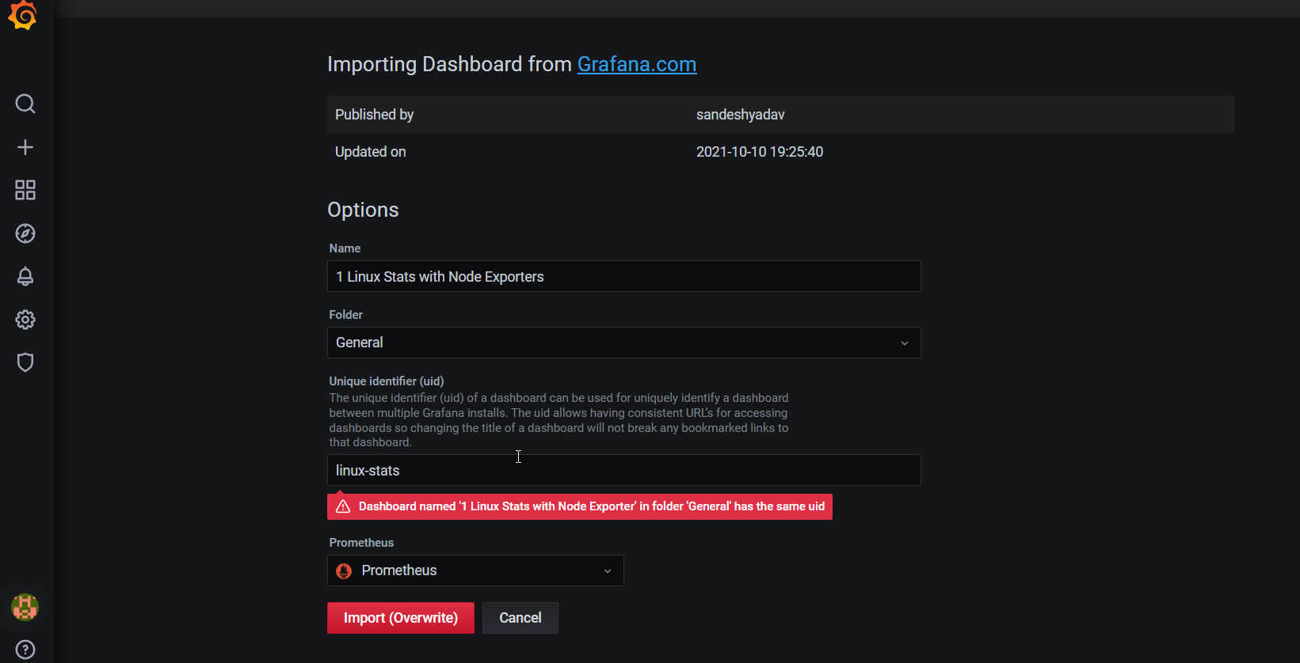

Monitoring dashboard setup is done only for Linux

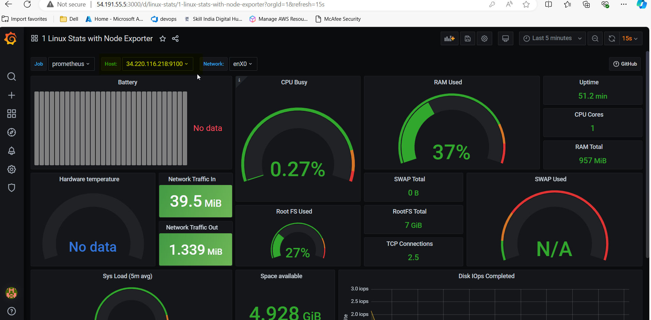

Trying to create alert:

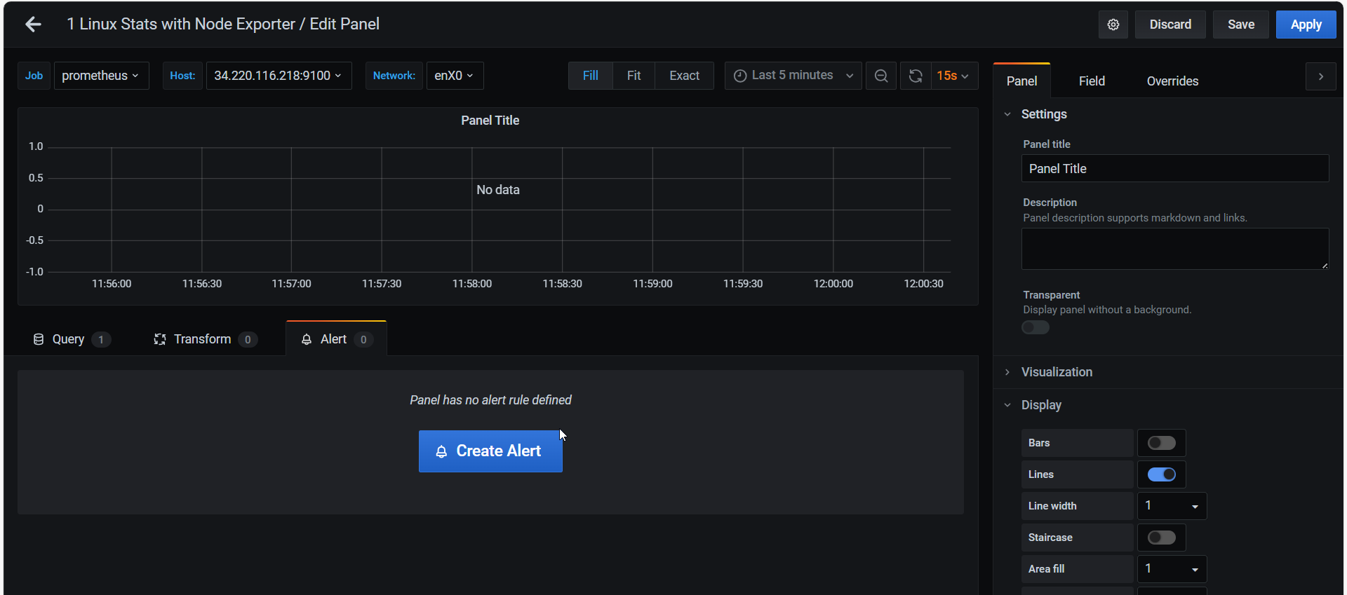

Creating alert if uptimes goes down to zero:

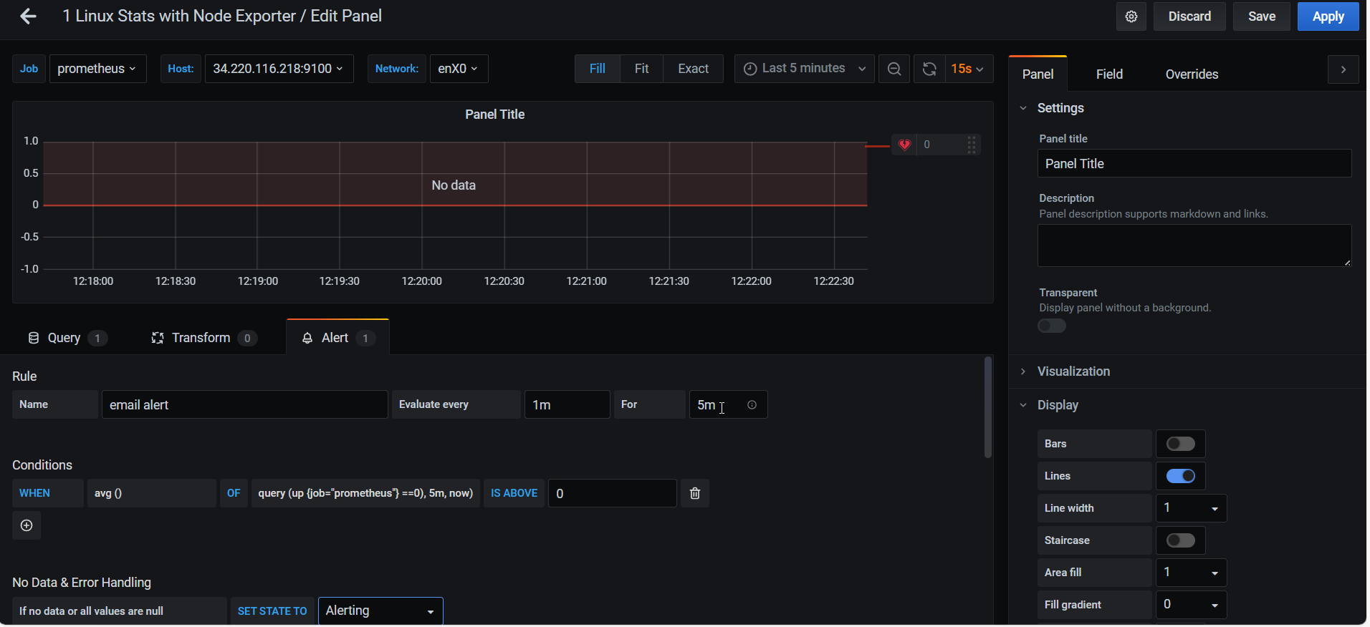 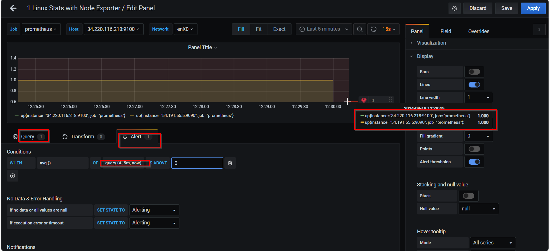

Couldn’t configure email fyi.